

IT-Risk Management

User Guide Release M7 February 2020

**Copyright Notices**

Copyright © 1999-2020 MetricStream Inc. All Rights Reserved.

The IT-Risk Management App Navigation Guide Release M7 February 2020 may have been furnished under license for use only within the terms of that license and may contain confidential information of MetricStream. If you do not have a valid non disclosure agreement with MetricStream, or a valid contract for use of this document, then you received this document without authorization and are not legally entitled to possess, read or use it. Usage, duplication, and disclosure of IT-Risk Management App Navigation Guide Release M7 February 2020 are subject to limitations by the US Government as Restricted Rights Software under the applicable contract, federal laws and regulations including FAR and DFAR. The information and the illustrations provided in the document are subject to change without notice. MetricStream disclaims all warranties and liability for any inaccuracies or errors herein.

Written and designed at MetricStream, Inc., 2479 East Bayshore Road, Palo Alto, CA 94303, U.S.A. Printed in the U.S.A.

**Contents**

Overview 5

Key Components 6

Module-level User Guide 7

Security Model 8

Roles, Privileges, and Infocenters 8

App Pages 9

App Home Page 10

Overview 11

Heat Maps 11

Process Risk Posture Chart 11

Asset Risk Posture Chart 14

Assets Open Issues Chart 15

Issues by Status Chart 17

Issues by Rating Chart 17

Issues by Priority Chart 18

Asset Class Risk Posture Heat Map 20

Organization Risk Posture Heat Map 22

Assessments 24

My Risk Assessments Report 25

Ongoing Assessments Report 25

Risk Assessment Plans Report 26

Forms 26

Reports 27

Dashboards 28

Threats 29

Threats by Threat Strength Chart 29

Threats by Likelihood of Initiation Chart 30

Forms 30

Reports 31

Vulnerabilities 35

Vulnerabilities Metric Cards 35

Remediation Incidents by Status 36

Dashboards 36

Vulnerabilities by Severity 37

Vulnerability by Exposure Chart 38

Remediation Issues by Status Chart 38

Remediation Issues by Rating Chart 39

Remediation Issues by Priority Chart 40

Remediation Incidents by Status 40

Remediation Incidents by Impact 41

Remediation Incidents by Urgency 42

Forms 43

Reports 44

Related Vulnerabilities 48

Related Controls 48

Related Risks 48

Related Threat 49

Libraries 50

Risks Report. 50

Asset Classes 51

Forms 51

Reports 52

Issues 54

My Issues Report 54

My Actions Report 55

Forms 55

Reports 56

Setup (ITGRC Apps Administrator) 57

Forms 57

Reports 63

Setup (for other users) 65

Forms 65

Reports 71

Managing Connectors Dashboard 72

Appendix 98

Supported Special Characters 99

Glossary 100

References 101

# Overview

The IT-Risk Management App Guide gives you a simple overview of the navigation within the **IT-Risk Management App**, the most common functionalities and some reference guidelines which you can use while working on the App.

This guide is intended for IT-Risk Managers, IT-Risk Analysts and IT - Risk Assessors who can use this as a reference document while working on the App.

The App provides a configurable framework that enables Information Security Groups to adopt a business-driven approach to manage information security and information technology risks. It also, helps in identifying, assessing, and treating information security risks on business critical processes, information technology assets and applications.

The App provides capability to document the Risks, defining and managing mitigating controls, performing multi- dimensional risk assessments, identifying issues, and implementing recommendations and remediation plans along with powerful analytics, dashboards and reporting.

###### Sections:

* Key Components
* Module-level User Guide

## Key Components

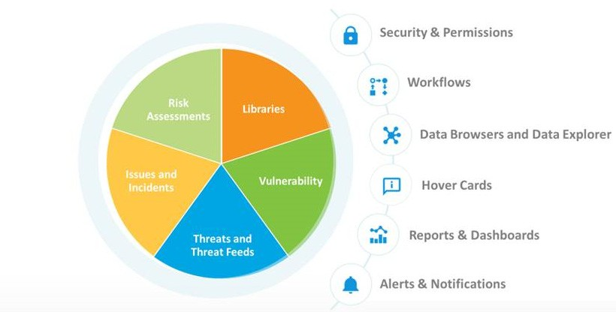The following figure illustrates the key components of the IT-Risk Management App.

**Figure 1** IT-Risk Management Key Components

The key components help organizations identify, record, manage, and assess risks as well as to take appropriate actions to keep risk under control. The following table describes the key components of the IT-Risk Management App

|  |  |
| --- | --- |
| **Key Component** | **Description** |
| **Issues** | Logs findings/issues that are raised during Risk assessments and implements relevant actions to remediate the possible issues. |
| **Libraries** | Hosts the library contents such as Risks, Controls, Assets, Asset Classes, and Processes related to IT- Risk. With Libraries, you can manage all framework library contents that are required for managing the IT-Risk . |
| **Risk Assessments** | Provides a centralized risk framework to document, manage, and assess IT-risks faced by an organization. With Risk Assessments, you can keep your organizations up-to-date with business changes and provide mechanisms to evaluate the changes against the evolving threat landscape, emerging trends, and new technologies. It also provides valuable information to help organizations to decide, whether additional controls are necessary to protect sensitive data and other important business assets. |
| **Threat and Threat Feeds** | Gains the insight into the list of threats. Ability to capture adhoc threat alert details, threats and their actors. Also, configure channels, subscriptions, remediation templates and remediation rules. |
| **Vulnerability** | Gains the insight into the list of vulnerabilities. Ability to capture vulnerability details to identify the severity and their exposure level. |

## Module-level User Guide

Overview

Click the respective links in the following table to open the component-level user guides.

|  |  |
| --- | --- |
| **Guide** | **Read this guide to...** |
| Governance, Risk, and Compliance Foundation User Guide | Know about the list of GRC library types, general approval workflow of the GRC library items, form-level details of each library type, and the GRC library-related reports. |
| Risk Assessment User Guide | Understand the risk assessment approach, approval workflow (Plan and assessment), risk assessment setup (Including form level details for perspective, quantitative factors, qualitative factors, scoring algorithm, risk assessment profile), details on how to create risk assessment plans, how to perform risk assessments, various assessment methods, heat maps, reports, and charts. |
| Issues User Guide | Learn the issues workflow, know the details on initiating and managing issues, implementing action plans, monitoring and closing issues, reopening and updating issues, bulk reassignment, data upload, reports, and charts. |
| Threat and Vulnerabilities User Guide | Learn the threat and vulnerability security model with the roles and privileges. Details on how to manage threats (capturing, editing and reviewing threat actor details and threat details). Also, details on managing the connectors dashboard (pulling in vulnerability assessments form external scanning tools). |
| GRC Intelligence | Understand the details on GRC intelligence process flow, channel, ad hoc alerts, channel group, channel subscription, subscribed content access, log issues, reports, and charts. |

**Note:** If the preceding links are not accessible on browser, download and open this PDF guide in Adobe Acrobat.

# Security Model

The **IT-Risk Management** App operates based on the access rights of users. The security model structure is defined when you:

* Create roles and assign infocenters and activities to the roles, as required
* Create organization structure and organization-role pair
* Assign users to organization-role pair

**Note:** Contact your system administrator to perform the above mentioned actions.

## Roles, Privileges, and Infocenters

The following table lists the different roles, privileges and related infocenters in the **IT-Risk Management** App.

|  |  |  |
| --- | --- | --- |
| **Role** | **Privilege** | **Infocenter/Page** |
| IT - Risk Manager | Review and approve:   * Library contents * Risk Assessment plans * Risk assessments * Issues | * Overview * Assessments * Threats * Vulnerabilities * Libraries * Issues * Setup |
| IT - Risk Analyst | Create, view, Review, and edit:   * Library contents * Risk Assessment plans * Risk assessments * Issues | * Overview * Assessments * Threats * Vulnerabilities * Libraries * Issues * Setup |
| IT - Risk Assessor | Perform and work on:   * Risk assessments * Issue remediation | * Assessments * Issues |
| ITGRC Apps Administrator | Configure API users to create GRCF Libraries | * ITGRC Apps Administration   + Setup |
| ITR LOB-Head | Review and approve:   * Library contents * Risk Assessment plans * Risk assessments * Issues | * Overview * Assessments * Threats * Vulnerabilities * Libraries * Issues * Setup |

**Note:** The infocenter is referred to as 'page' throughout the document.

# App Pages

This chapter provides detailed information on landing pages and the components available in the landing pages of the **IT-Risk Management** App.

###### Sections:

* App Home Page
* Overview
* Assessments
* Threats
* Vulnerabilities
* Libraries
* Issues
* Setup (ITGRC Apps Administrator)
* Setup (for other users)

## App Home Page

App home page is a structured, user focused, default page that appears when you log on to the App. The home page can consist of metric cards, reports, and charts which give a quick overview on the tasks that you can perform.

The default components of the home page vary according to the role. You can customize your home page according to your requirement.

For information on customizing the home page, refer to the MetricStream Platform User Guide Release M7 February 2020.

The following page is a sample home page available to an **IT Risk Analyst**:

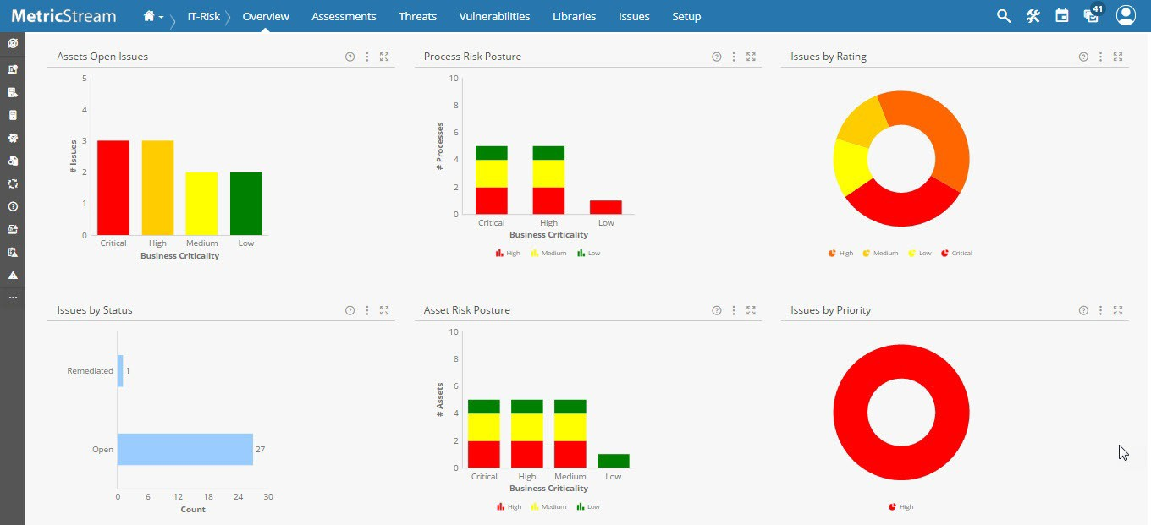

**Figure 2** App Home Page

## Overview

The **Overview** page (infocenter) allows you to access reports that provide valuable risk insights and aggregated IT- Risk information on IT- Assets, IT - Processes, IT-Asset Classes, and Organizations. It also provides the enterprise-wide visibility into the IT-Risk management related details. The details in this page helps in identifying the potential opportunities for improvements.

The following **Overview** page is available for an IT - Risk Analyst. For more information on the role-infocenter/ privilege mapping, see Roles, Privileges, and Infocenters.

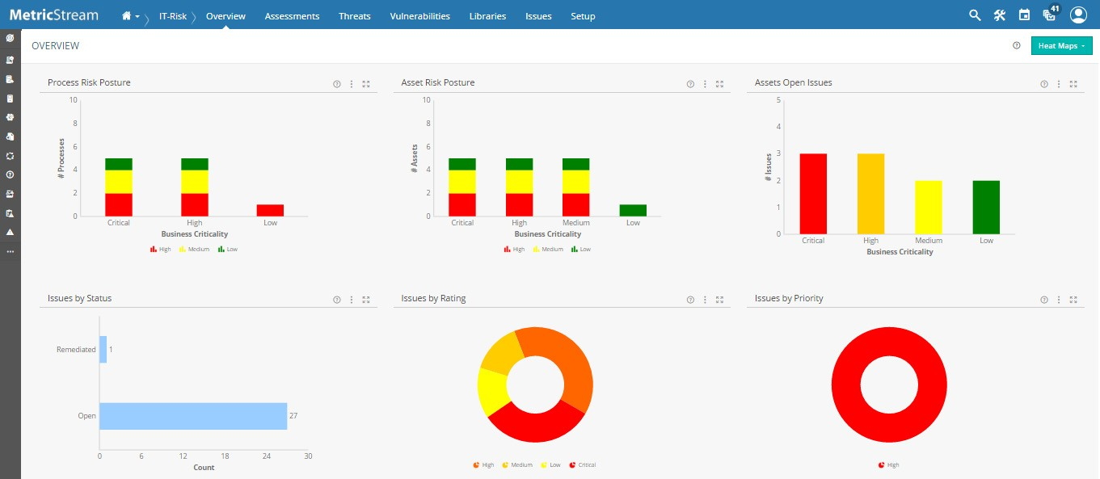

**Figure 3** Overview Page

### Heat Maps

Use the links within the **Heat Maps** drop-down list to access the heat map charts available in **IT- Risk Management**

App, as shown in the following figure.

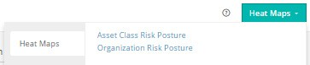

**Figure 4** Heat Maps of Overview

You can access the following heat map reports:

* **Asset Class Risk Exposure**: Opens the **Asset Class Risk Posture Heat Map**. For more information on heat map, see Asset Class Risk Posture Heat Map.
* **Organization Risk Exposure**: Opens the **Organization Risk Posture Heat Map**. For more information on heat map, see Organization Risk Posture Heat Map.

### Process Risk Posture Chart

The **Process Risk Posture** chart displays the summary of processes in the system that are risk assessed.

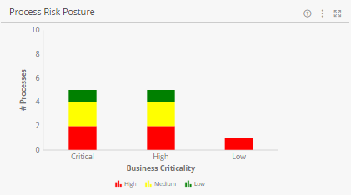

**Figure 5** Process Risk Posture Chart

The hover number on a colored stack indicates the number of processes for that risk rating under the corresponding Business Criticality.

For example, when you hover over the red stack in **Critical** business criticality bar and it shows 2, then the number of processes with High risk rating is **2**. Similarly, when you hover on yellow and it shows 3, then the number of processes with Medium risk rating is **3**.

When you click any one of the colored stacks, the drill down Process Risk Posture Report opens. It displays a combined list of processes having different risk ratings and same Business Criticality.

|  |  |
| --- | --- |
| **Description** | **Drill Down** |
| The bar chart illustrates the following:   * X-axis: Represents the Business criticality of Process * Y-axis: Represents the count of processes   The following are the stack details:   * High: Number of processes rated high for a process criticality * Medium: Number of processes rated medium for a process criticality * Low: Number of processes rated low for a process criticality | Process Risk Posture Report |

#### Process Risk Posture Report

The **Process Risk Posture** report is a drill down of the **Process Risk Posture** chart. This report displays the combined view of Business Criticality of a process and it's Risk Rating that allows you to identify the risky Processes. For example: A Process with Business Criticality = Low and Risk Rating = High is not as risky as a Process with Business Criticality = Critical and Risk Rating = High.

|  |
| --- |
| displays Process Risk Posture Report |

**Figure 6** Process Risk Posture Report

###### Key Columns:

* **Process Name:** Displays the name of the process that is risk assessed.
  + Place the pointer on the name of the Process to view the hover card. Click the process name to view the details of the process.
  + You can also view the related processes and organization to which the process is mapped. Click Reports icon in the hover card and scroll down, to view all the related reports.
* **Related to Assets:** Displays the asset to which the risk assessed process is associated.
* **Related to Organizations:** Displays the organization to which the risk assessed process is associated.

### Asset Risk Posture Chart

The **Asset Risk Posture** chart displays the summary of assets in the system that are risk assessed. The assets are identified based on the on the total number of assets within an asset class.

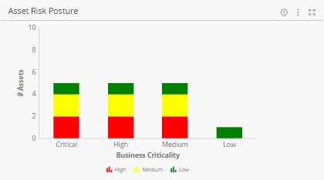

**Figure 7** Asset Risk Posture Chart

The hover number on a colored stack indicates the number of assets for that risk rating under the corresponding Business Criticality.

For example, when you hover over the red stack in **Critical** business criticality bar and it shows 2, then the number of assets with High risk rating is **2**. Similarly, when you hover on yellow and it shows 3, then the number of assets with Medium risk rating is **3**.

When you click any one of the colored stacks, the drill down Asset Risk Posture Report opens. It displays a combined list of assets having different risk ratings and same Business Criticality.

|  |  |
| --- | --- |
| **Description** | **Drill Down** |
| The bar chart illustrates the following:   * X-axis: Represents the Business criticality of asset * Y-axis: Represents the count of assets   The following are the stack details:   * High: Number of assets rated high for a business criticality * Medium: Number of assets rated medium for a business criticality * Low: Number of assets rated low for a business criticality | Asset Risk Posture Report |

#### Asset Risk Posture Report

The **Asset Risk Posture** report is a drill down of the **Asset Risk Posture** chart. This report displays the combined view of Business Criticality of an Asset and its Risk Rating that allows you to identify the risky assets. For example, an Asset with Business Criticality = Low and Risk Rating = High is not as risky as an Asset with Business Criticality

= Critical and Risk Rating = High.

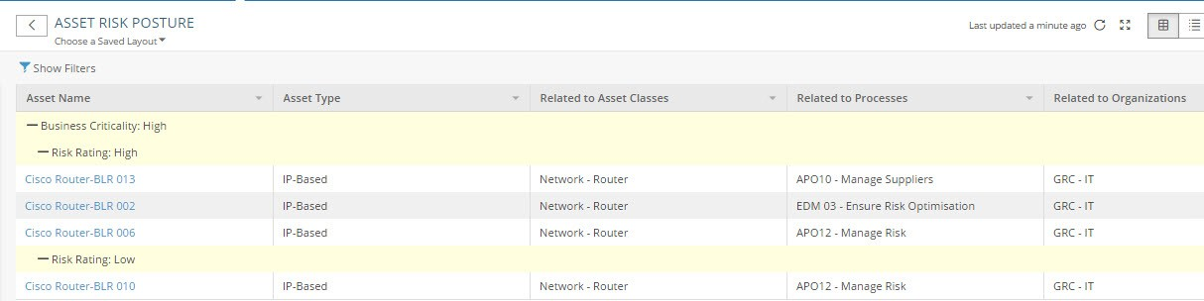

**Figure 8** Asset Risk Posture Report

###### Key Columns:

* **Asset Name:** Displays the name of the asset that is risk assessed.
  + Place the pointer on the name of the asset to view the hover card. Click the asset name to view the details of the asset.
  + You can also can view the related asset class and organization to which the asset belongs. Click  in the

hover card and scroll down, to view all the related reports.

* **Related to Asset Classes:** Displays the asset classes to which the risk assessed asset is associated.
* **Related to Organizations:** Displays the organization to which the risk assessed asset is associated.

### Assets Open Issues Chart

The **Assets Open Issues** chart displays the summary of open issues against the assets in the system.

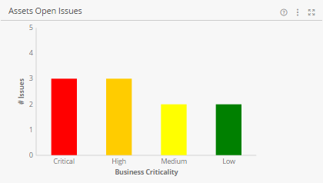

**Figure 9** Assets Open Issues Chart

|  |  |
| --- | --- |
| **Description** | **Drill Down** |
| The bar chart illustrates the following:   * X-axis: Represents the Asset Business criticality * Y-axis: Represents the count of Issues   The following are the stack details:   * High: Number of issues open for an Asset business criticality which is rated high * Medium: Number of issues open for an Asset business criticality which is rated medium * Low: Number of issues open for an Asset business criticality which is rated low | Assets Open Issues Report |

#### Assets Open Issues Report

The **Assets Open Issues** report is a drill down of the **Assets Open Issues** chart. This report displays the details of open issues against the asset.

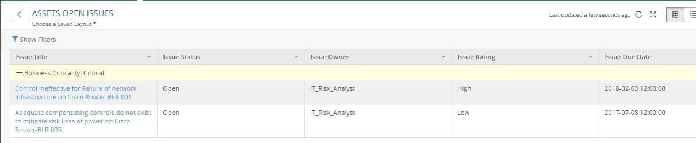

**Figure 10** Assets Open Issues Report

###### Key Columns:

* **Issue Title:** Displays the name of the issue. Place the pointer on the name of the Issue to view the hover card. Click the Issue Title to view the details of the Issue. Also, you can view the related Asset to which the issue is related.
  + Drill Down: **Issue** form.
* **Issue Due Date:** Displays the date by which the issue remediation is due.
* **Assets:** Displays the asset to which the issue is open.

### Issues by Status Chart

The **Issues by Status** chart displays the number of issues in the system which are in different statuses.

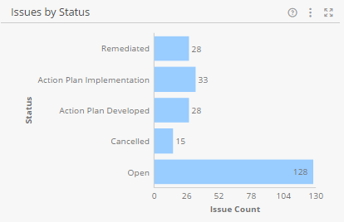

**Figure 11** Issues by Status Chart

|  |  |
| --- | --- |
| **Description** | **Drill Down** |
| The bar chart illustrates the following:   * X-axis: Represents the status of the issue * Y-axis: Represents the number of issues | Issues Report  For details, refer to the MetricStream Issues User  Guide Release 7.0 SP1. |

### Issues by Rating Chart

The **Issues by Rating** chart displays the number of issues based on the issue rating.

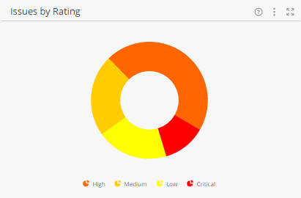

**Figure 12** Issues by Rating Chart

|  |  |
| --- | --- |
| **Description** | **Drill Down** |
| The pie chart illustrates the following:   * High: Represents the number of issues rated high * Medium: Represents the number of issues rated medium * Low: Represents the number of issues rated low * Critical: Represents the number of issues rated critical   **Notes:**   * This chart displays all the issues that have passed through the manage issue stage. * The rating is considered for issues that are in the   **Open** status. The status of the issue is termed as **Open** when it is any of the workflow stages other than **Closed** or **Canceled**. | Issues Report  For details, refer to the MetricStream Issues User Guide Release 7.0 SP1. |

### Issues by Priority Chart

The **Issues by Priority** chart displays the number of open issues based on priority.

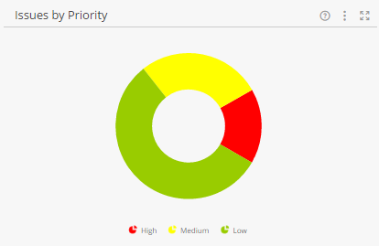

**Figure 13** Issues by Priority Chart

|  |  |
| --- | --- |
| **Description** | **Drill Down** |
| The pie chart illustrates the following:   * High: Represents the number of open issues which are of high priority * Medium: Represents the number of open issues which are of medium priority * Low: Represents the number of open issues which are of low priority | Issues Report  **Note:** For details, refer to the MetricStream Issues User Guide Release M7 February 2020. |

#### Issues Report

The **Issues** report displays the details of issues triggered in the system.

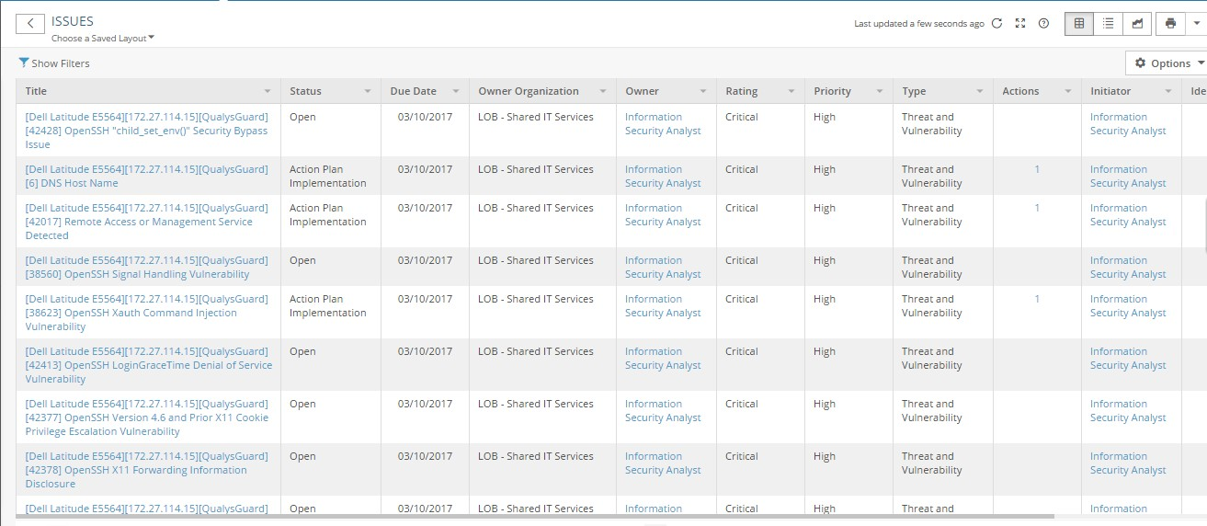

**Figure 14** Issues Report

###### Key Columns:

* **Title:** Displays the title of the issue.
  + Drill Down: **Issue** form
* **Status:** Displays the status of the issue.
* **Owner:** Displays the name of the issue owner. Move the mouse pointer over this field to view the hover card.

**Note:** For details, refer to the MetricStream GRC Foundation User Guide Release M7 February 2020.

* **No. of Actions:** Displays the number of actions associated with the issue.
  + Drill Down: **Actions** report

**Note:** For more details, refer to the MetricStream Issues User Guide Release M7 February 2020.

### Asset Class Risk Posture Heat Map

The **Asset Class Risk Posture Heat Map** chart displays risky asset classes which needs attention to mitigate the associated risks. The chart plots the asset classes based on the total number of assets within an asset class as well as the % of assets which has the same risk rating. For example, if an asset class contains 1% of its Assets in High Risk and this 1% is equal 1,000 Assets, then the IT Risk manager should pay attention to this type of risk and prioritize to mitigate the risk.

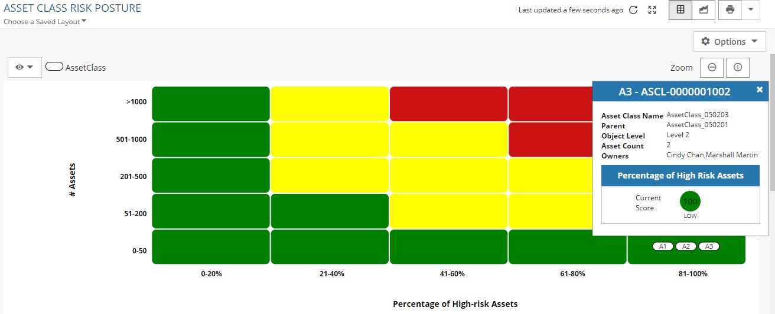

**Figure 15** Asset Class Risk Posture Heat Map

|  |  |
| --- | --- |
| **Description** | **Drill Down** |
| The heat map illustrates the following:   * X-axis: Percentage of high risk assets * Y-axis: Count of assets | Asset Class Risk Posture Report |

#### Asset Class Risk Posture Report

The **Asset Class Risk Posture** report is a drill down report of **Asset Class Risk Posture Heat Map** chart. This report displays the details of risky Asset classes by using the total number of Assets within an Asset class.

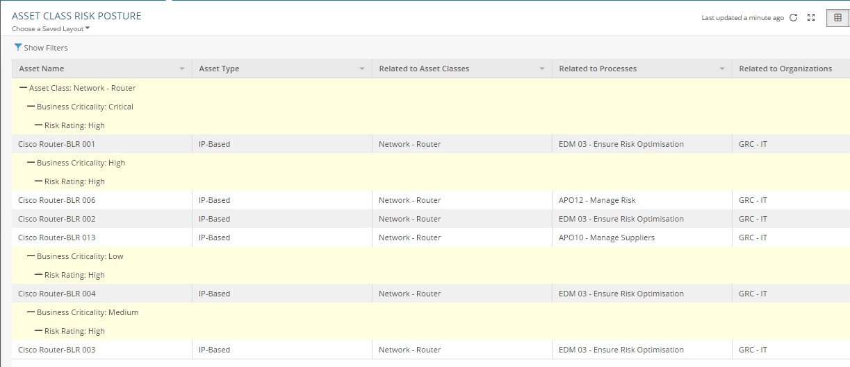

**Figure 16** Asset Class Risk Posture Report

###### Key Columns:

* **Asset Name:** Displays the name of the asset which is risk assessed.
* **Related to Asset Classes:** Displays the asset classes to which the risk assessed asset is associated.
* **Related to Organizations:** Displays the organization to which the risk assessed asset is associated.

### Organization Risk Posture Heat Map

The **Organization Risk Posture Heat Map** chart displays risky organizations which needs attention to mitigate the associated risks. The chart plots the organizations based on the total number of organizations related to an asset which has the same risk rating. For example, if an organization contains 1% of its Assets in High Risk and this 1% is equal 1,000 Assets, then the IT Risk manager should pay attention to this type of risk and prioritize to mitigate the risk.

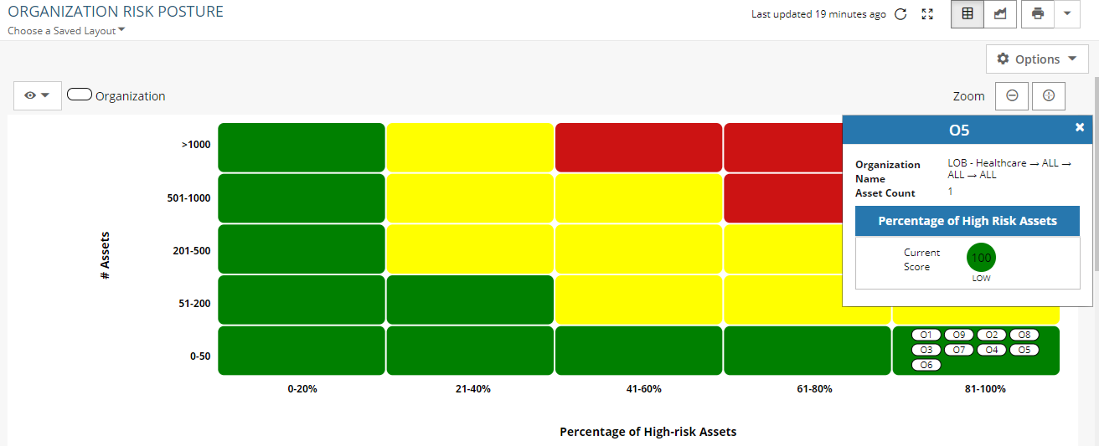

**Figure 17** Organization Risk Posture Heat Map

|  |  |
| --- | --- |
| **Description** | **Drill Down** |
| The heat map illustrates the following:   * X-axis: Percentage of high risk assets * Y-axis: Count of assets | Organization Risk Posture Report |

#### Organization Risk Posture Report

The **Organization Risk Posture** report is a drill down report of **Organization Risk Exposure Heat Map** chart. This report displays the details of risky organizations by using the total number of Assets related to an organization.

|  |
| --- |
| displays Organization Risk Posture Report |

**Figure 18** Organization Risk Posture Report

###### Key Columns:

* **Asset Name:** Displays the name of the asset which is risk assessed.
* **Related to Asset Classes:** Displays the asset classes to which the risk assessed asset is associated.
* **Related to Organizations:** Displays the organization to which the risk assessed asset is associated.

## Assessments

Use the **Assessments** page to schedule risk assessments, assess risks and controls, log findings and issues, and reassess risks. The following **Assessments** page is available for IT- Risk Manager and IT- Risk Analyst. For more information on the role-infocenter/privilege mapping, see Roles, Privileges, and Infocenters.

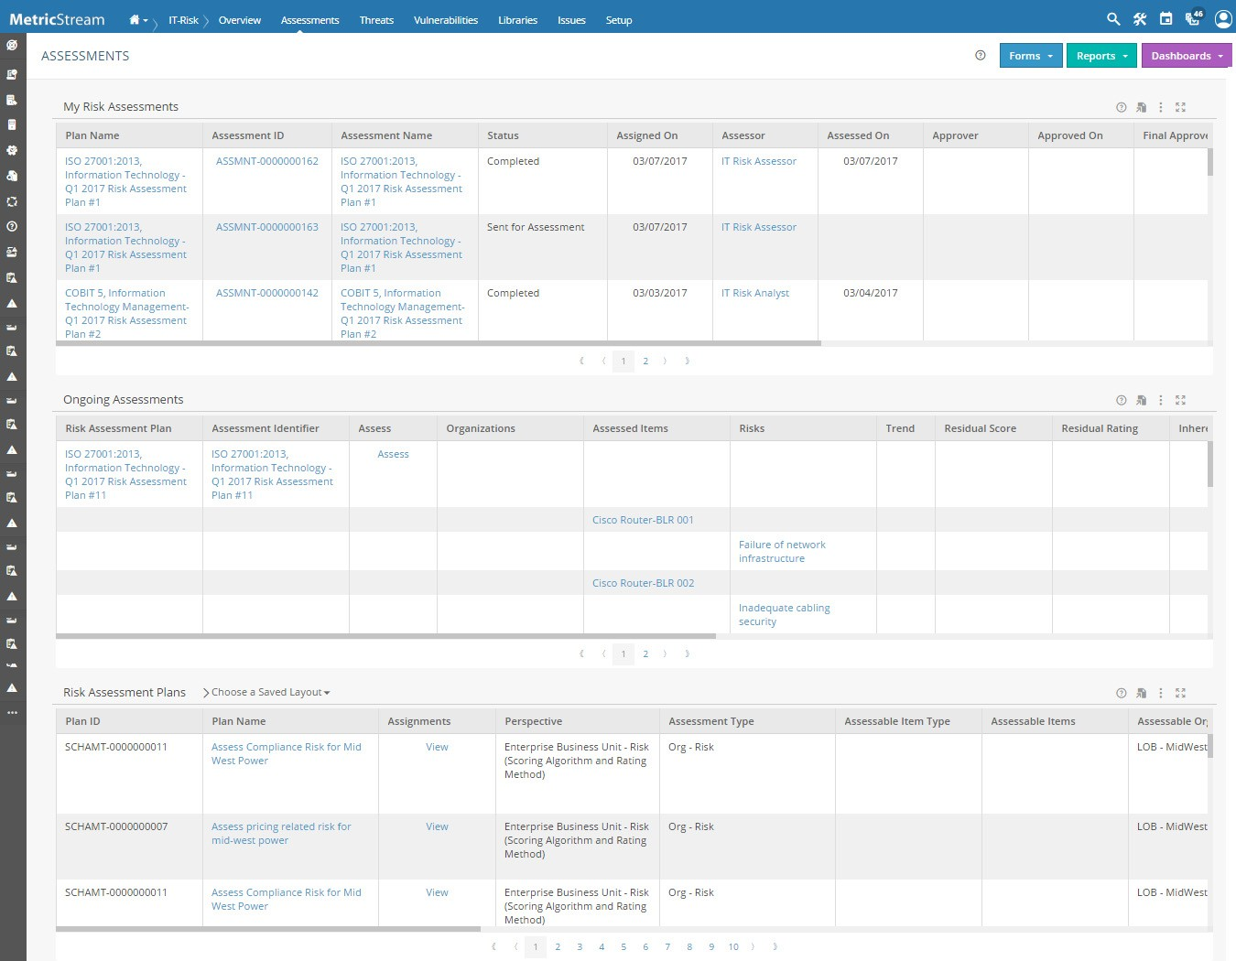

**Figure 19** Assessments Page

### My Risk Assessments Report

Use the **My Risk Assessments** report to view and work on the risk assessments assigned to you.

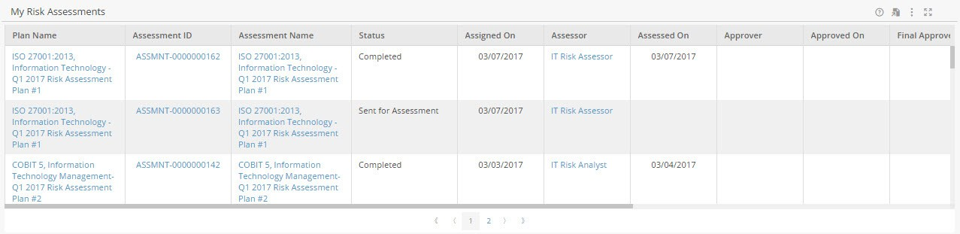

**Figure 20** My Risk Assessments Report

###### Key Columns:

* **Plan Name:** Displays the name of the risk assessment plan which you need to assess.
* **Assessment ID:** Displays the identification number of the risk assessment plan.
  + Drill Down: **Risk Assessment** form

### Ongoing Assessments Report

Use the **Ongoing Assessments** report to view and work on the ongoing risk assessments.

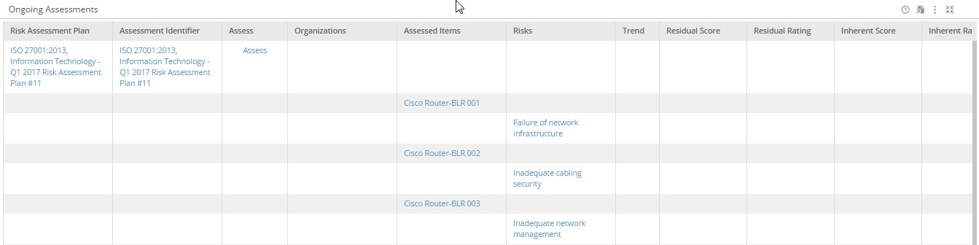

**Figure 21** Ongoing Assessments Report

###### Key Columns:

* **Risk Assessment Plan:** Displays the name of the risk assessment plan which needs to be assessed.
* **Trend:** Displays the trend based on the rating.
* **Assess:** Displays the 'Assess' link.
  + Drill Down: **Risk Assessment** form

### Risk Assessment Plans Report

Use the **Risk Assessment Plans** report to view all the risk assessment plans in the system.

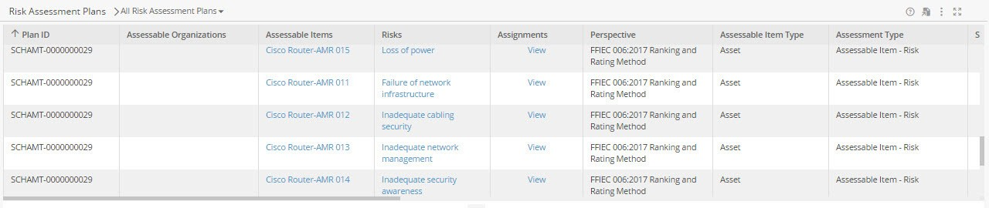

**Figure 22** Risk Assessment Plans Report

###### Key Columns:

* **Plan Name:** Displays the name of the risk assessment plan which needs to be assessed.
* **Assessment Type:** Displays the type of assessment applicable for a specific assessment plan.
* **Risks:** Displays the name of the risk against which the assessment needs to be done.

### Forms

A risk assessment is required to identify, assess, and mitigate risks. A risk assessment plan involves identifying scope of assessment, specifying the frequency of assessments, risk assessors, and approvers. You can also create tasks for the plans to meet the immediate requirements. Use the links within the **Forms** drop-down list, as shown in the following figure, to manage risk assessments.

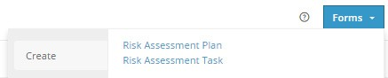

**Figure 23** Forms of Assessments

You can create the following risk assessments/tasks:

* **Risk Assessment Plan:** Opens the **Risk Assessment Plan** form, where you can set up the risk assessment plan.
* **Risk Assessment Task:** Opens the **Risk Assessment Task** form, where you can create risk assessment tasks for the existing risk assessment plans.

**Note:** For details, refer to the MetricStream Risk Assessments User Guide Release M7 February 2020.

### Reports

Use the links within the **Reports** drop-down list to access the reports available in the **IT- Risk Management** App, as shown in the following figure.

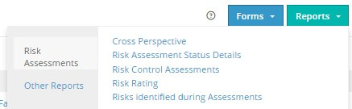

**Figure 24** Reports of Assessments

The **Reports** button has two links within it:

* Risk Assessments Link
* Other Reports Link

#### Risk Assessments Link

Within **Risk Assessments** link, you can access the following key reports:

* **Cross Perspective Report:** Opens the **Cross Perspective** report, which provides the Risk Assessment Type assessment (Assessable Item - Risk and Org - Assessable Item - Risk and Perspective values to view the required details. This report provides information on IT-assets and processes that are assessed based on different risk assessment perspective scope for a specified type of risk assessment.
* **Risk Assessment Status Details Report:** Opens the **Risk Assessment Status Details** report, which provides the number of days for which you want to view the plan and risk assessment task details. This report displays the current status of all the risk assessments that are assigned to the assessors along with its risk assessment workflow status. By default, the report displays the data of assessments assigned in the past one month.
* **Risk Control Assessments Report:** Opens the **Risk Control Assessments** report, which displays the details of control rating done as part of the risk assessments performed within a chosen perspective.
* **Risk Rating Report:** Opens the **Risk Rating** report, which provides the Risk Assessment Type to view the risk rating details. This report displays the inherent, residual and assessment details of the specified type of risk assessment (Assessable Item - Risk and Org - Assessable Item - Risk).
* **Risks Identified During Assessments Report:** Opens the **Risk Identified During Assessments** report, which displays the list of Risks added during the risk assessment.

#### Other Reports Link

Within **Other Reports** link, you can access the following key reports:

* **Inherent Risks Breakdown by Category:** Opens the **Inherent Risks Breakdown by Category** report, which provides the Perspective value to view the required details. This report provides information on the Inherent Risk ratings of different risk categories that are assessed for the specified Perspective.
* **Residual Risks Breakdown by Category:** Opens the **Residual Risks Breakdown by Category** report, which provides the Perspective value to view the required details. This report provides information on the Residual Risk ratings of different risk categories that are assessed for the specified Perspective.
* **Risk Register:** Opens the **Risk Register** report, which provides end-to-end assessment details of the latest assessments performed. This report also provides details on the organizations, assessable entities, risks and factors that were assessed, and their contribution to the overall assessments.

**Note:** For details, refer to the MetricStream Risk Assessments User Guide Release M7 February 2020.

### Dashboards

Use the links within the **Dashboards** drop-down list to access the key charts available in the **IT- Risk Management**

App, as shown in the following figure.

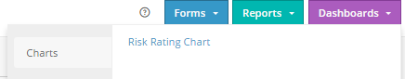

**Figure 25** Dashboards of Assessments

You can access the following key report:

* **Risk Rating Chart:** Opens the **Risk Rating Chart** report. Specify the Assessment Name and Perspective to view the risk score details.

**Note:** For details, refer to the MetricStream Risk Assessments User Guide Release M7 February 2020.

## Threats

Use the **Threats** page to gain insight into the list of threats through the threats by threat strength chart and threats by likelihood of initiation chart. You can capture ad hoc threat alert details, the details of different threats, and threat actors to identify the strength of the threat and possibility of the threat being carried out. You can also view reports related to threats and threat actors.

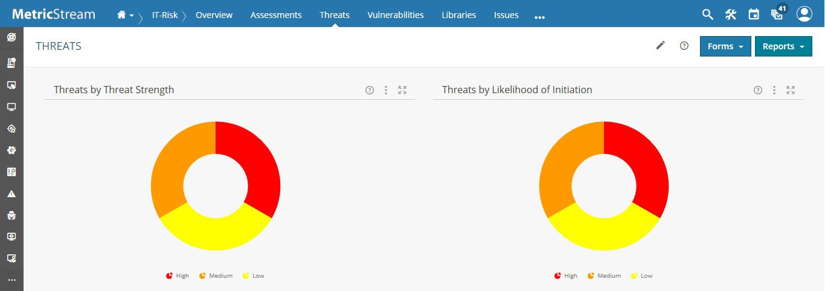

**Figure 26** Threats

### Threats by Threat Strength Chart

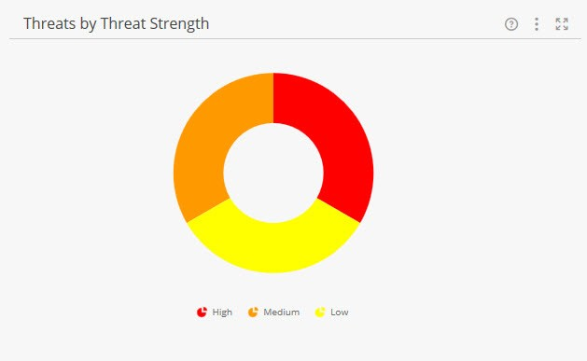

**Figure 27** Threats by Threat Strength Chart

|  |
| --- |
| **Description** |
| This pie chart displays the number of threat records based on their strength, such as High, Medium, and Low. |
| **Drill down:** |
| **Threats** report |

### Threats by Likelihood of Initiation Chart

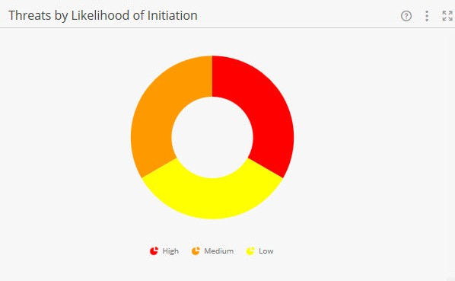

**Figure 28** Threats by Likelihood of Initiation Chart

|  |
| --- |
| **Description** |
| This pie chart displays the number of threat records based on their likelihood of initiation, such as High, Medium, and Low. |
| **Drill down:** |
| **Threats** report |

### Forms

Click **Forms** and use the appropriate forms to capture the details of ad hoc alerts, different threats, and threat actors. Use links within the **Forms** button to access the available key forms, as displayed in the following figure.

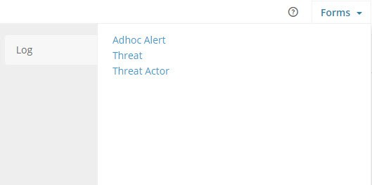

**Figure 29** Threats Forms

|  |  |
| --- | --- |
| **Forms** | **Description** |
| **Adhoc Alert** | Use this form to capture ad hoc alert details. |
| **Threat** | Use this form to capture the details of different threats, assess the threats, and identify its strength and possibility of the threat being carried out. |
| **Threat Actor** | Use this form to capture the details of different threat actors and assess their motives. |

**Note:** For more information on capturing details of ad hoc alerts, threats, and threat actors, refer Managing Threats.

### Reports

Click **Reports** and view the required reports related to threats.

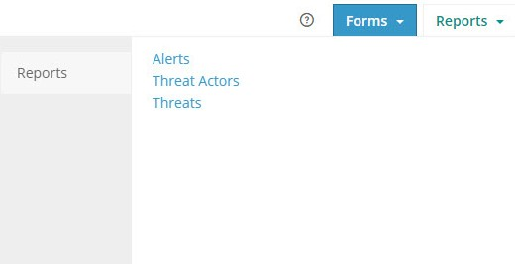

**Figure 30** Threats Reports

The following table provides the list of the threat related reports.

|  |  |
| --- | --- |
| **Reports** | **Drill-down Reports** |
| Alerts |  |
| Threat Actors | * Motive Details * Capability Details |
| Threats | * Threat Actors * Related Assets * Related Asset Classes |

#### Alerts

The Alerts report provides the list of threat alert channels from various subscriptions along with the detailed threat information.

Information Security Analyst can view and analyze the list of Alerts subscribed from RSS or Email based threat alert Channels. Trigger threat remediation workflow for prioritized threats and log findings or issues to respective issue owners to track the applicability response.

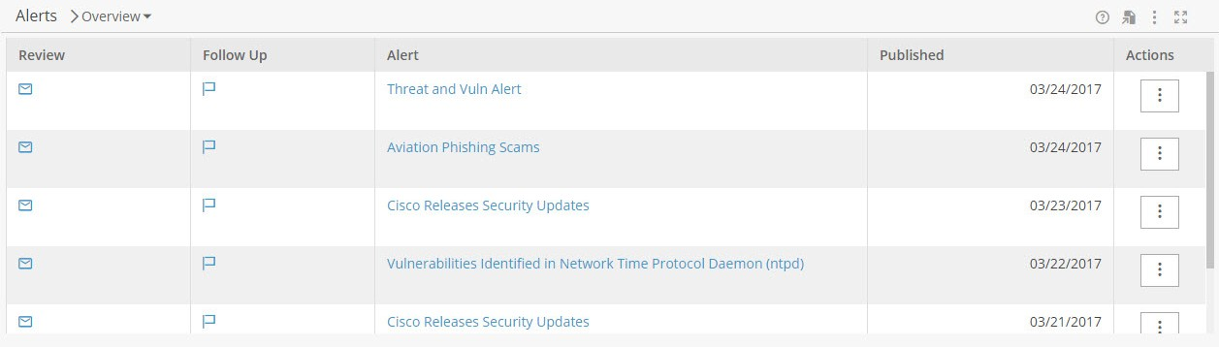

**Figure 31** Alerts Report

For more information, refer to the Governance, Risk, and Compliance Intelligence User Guide Release M7 February 2020.

#### Threat Actors

|  |
| --- |
| **Use this report to:** |
| View the details of all the available threat actor details. |

###### Key Columns

|  |  |
| --- | --- |
| **Column** | **Description** |
| **Name** | Displays the name of the threat actor. Drill Down: **Threat Actor** form |
| **Motives** | Displays the number of motive details associated with the threat actor to carry out the threat.  Drill Down: Motive Details |
| **Confidentiality** | Displays the assessed confidentiality level for the motives of the threat actor. |
| **Integrity** | Displays the assessed integrity level for the motives of the threat actor. |
| **Availability** | Displays the assessed availability level for the motives of the threat actor. |
| **Capabilities** | Displays the number of capability details associated with the threat actor. Drill Down: Capability Details. |
| **Type** | Displays the type of threat actor. |
| **Sponsors** | Displays the sponsors for the threat actor. |
| **Region of Operation** | Displays the region of operation of the threat actor. |

#### Threats

|  |
| --- |
| **Use this report to:** |
| View the details of all the available threat details. |

###### Key Columns

|  |  |
| --- | --- |
| **Column** | **Description** |
| **Name** | Displays the name of the threat. Drill Down: **Threat** form |
| **Likelihood of Initiation** | Displays the assessed level for the likelihood of initiation of the threat. |
| **Threat Strength** | Displays the assessed level of the threat strength. |
| **Threat Vector** | Displays the path through which the threat can be initiated. |
| **Threat Actors** | Displays the number of threat actors associated with the threat. Drill Down: Threat Actors |
| **Confidentiality** | Displays the assessed confidentiality level for the threat actor details associated with the threat. |

|  |  |
| --- | --- |
| **Column** | **Description** |
| **Integrity** | Displays the assessed integrity level for the threat actor details associated with the threat. |
| **Availability** | Displays the assessed availability level for the threat actor details associated with the threat. |
| **Trend** | Displays the trend of the threat whether upward or downward. |
| **Threat Type** | Displays the type of threat. |
| **Issues** | Displays the number of internal issues captured for threat. |
| **Related to Assets** | Displays the number of assets associated with the threat. Drill Down: Related Assets. |
| **Related to Asset Classes** | Displays the number of asset classes associated with the threat. Drill Down: Related Asset Classes. |

#### Motive Details

|  |
| --- |
| **Use this report to:** |
| This is a drill down report from the Threat Actors report. You can view the details of all the motives associated with the selected threat actor. |

###### Key Columns

|  |  |
| --- | --- |
| **Column** | **Description** |
| **Motive** | Displays the name of the motive associated with the threat actor. |
| **Confidentiality** | Displays the confidentiality level of the motive. |
| **Integrity** | Displays the integrity level of the motive. |
| **Availability** | Displays the availability level of the motive. |

#### Capability Details

|  |
| --- |
| **Use this report to:** |
| This is a drill down report from the Threat Actors report. You can view the details of all the capabilities associated with the selected threat actor. |

###### Key Columns

|  |  |
| --- | --- |
| **Column** | **Description** |
| **Skill** | Displays the name of the skill associated with the threat actor. |
| **Skill Level** | Displays the skill level of the skill associated with the threat actor. |
| **Resource Level** | Displays the availability level of the resource for the threat actor to carry out the threat. |
| **Likelihood of Initiation** | Displays the likelihood of initiation level of threat by the threat actor. |

#### Threat Actors

|  |
| --- |
| **Use this report to:** |
| This is a drill down report from the **Threats** report. You can view the details of all the threat actors associated with the selected threat. |

###### Key Columns

|  |  |
| --- | --- |
| **Column** | **Description** |
| **Actor Name** | Displays the name of the threat actor. |
| **Skill** | Displays the name of the skill associated with the threat actor. |
| **Skill Level** | Displays the skill level for the skill associated with the threat actor. |
| **Resource Level** | Displays the availability level of the resource for the threat actor to carry out the threat. |
| **Likelihood of Initiation** | Displays the level of likelihood of initiation of threat by the threat actor. |
| **Confidentiality** | Displays the assessed confidentiality level for the motives of the threat actor. |
| **Integrity** | Displays the assessed integrity level for the motives of the threat actor. |
| **Availability** | Displays the assessed availability level for the motives of the threat actor. |

## Vulnerabilities

Use the **Vulnerabilities** page to gain insight into the list of vulnerabilities through vulnerabilities by severity chart and vulnerabilities by exposure charts. You can capture vulnerability details to identify the severity and exposure level of the vulnerability. You can also view reports of these vulnerabilities.

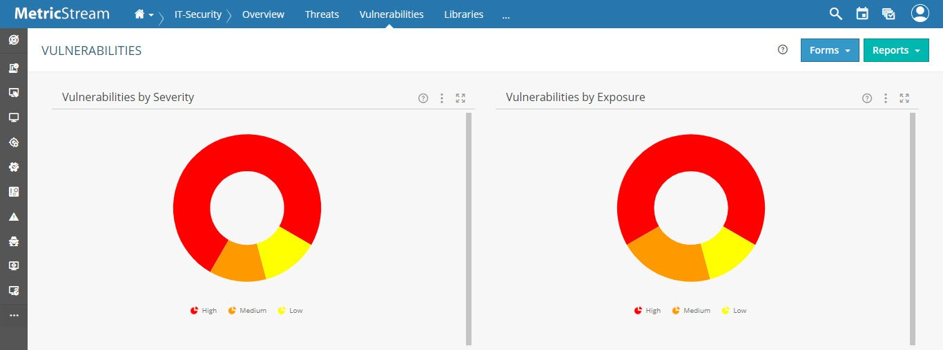

**Figure 32** Vulnerabilities

### Vulnerabilities Metric Cards

The **Metric Cards** summarizes the key metrics and displays the information in a nugget. The cards, when clicked upon, provides access to drill down reports, which analyses the key metric further. The cards are configurable based on your organization’s requirements. The following cards are available currently:

* The **Unassigned Vulnerabilities** metric card displays the aggregated count of identified vulnerabilities as per their combined risk rating. The count of identified vulnerabilities with top 2 combined risk ratings is also displayed. The Unassigned Vulnerabilities metric card summarizes any Asset – Vulnerability pair that does not have an associated Issue (That is, it did not match a Rule and it simply went to the default rule for computing a CRR – note that the Issue was not created either via. the Rule or via. the manual route). You can drill down to Unassigned Vulnerabilities report for details when required. Within the Unassigned Vulnerabilities, **Vulnerability Summary** is made a hyper-link. On click of the link, you can see the additional details of the vulnerability.
* The **Remediation Issues** metric card displays the aggregated count of issues auto triggered for identified vulnerabilities based on remediation rules. The count of remediation issues with top 2 combined risk ratings is also displayed. The count in these top 2 ratings (for example, **Critical** and **High**), is a subset of the aggregated count. When you click on any of these links, it drills down to Remediation Issues report. This report displays the details of the remediation issues, their combined risk rating details and the issue types.
* The **Remediation Incidents** metric card displays the aggregated count of incidents auto triggered for identified vulnerabilities based on remediation rules. The count of remediation incidents with top 2 combined risk ratings is also displayed. The count in these top 2 ratings (for example, **Critical** and **High**), is a subset of the aggregated count. When you click on any of these links, it drills down to Remediation Incidents report. This report displays the details of the remediation incidents, their combined risk rating details and the incident types.

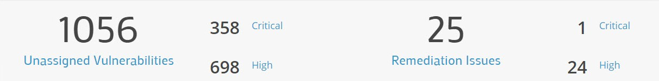

**1**

**2**

**3**

**4**

**Figure 33** Metric Cards of Overview (Issues)

The numbered callouts identify the following:

1. Aggregated count of unassigned vulnerabilities of the top 2 combined risk ratings is displayed.

Example: Total number of unassigned vulnerabilities comprising the top 2 ratings is 1056, as per the above image.

1. The count of unassigned vulnerabilities classified based on top 2 combined risk ratings is displayed.

Example: Number of unassigned vulnerabilities having critical combined risk rating is 358, and number having high combined risk rating is 698.

1. Aggregated count of remediation issues of the top 2 combined risk ratings is displayed.

Example: Total number of remediation issues comprising the top 2 ratings is 25, as per the above image.

1. The count of remediation issues classified based on top 2 combined risk ratings is displayed. Example: Number of remediation issues rated as critical is 1 and number rated as high is 24.
2. Aggregated count of remediation incidents of the top 2 combined risk ratings is displayed.

Example: Total number of remediation incidents comprising the top 2 ratings is 25, as per the above image.

1. The count of remediation incidents classified based on top 2 combined risk ratings is displayed. Example: Number of remediation incidents rated as critical is 1 and number rated as high is 24.

#### Unassigned Vulnerabilities

This report displays the list of Asset-Vulnerability pairs that does not have an associated Issue or Incident. The report classifies the asset-vulnerability pairs based on their combined risk ratings. You can search within the list by using filters.

#### Remediation Issues

This report displays the list of auto triggered issues for identified vulnerabilities. The report classifies the issues based on their combined risk ratings. You can search within the list by using filters.

#### Remediation Incidents

This report displays the list of auto triggered incidents for identified vulnerabilities. The report classifies the incidents based on their combined risk ratings. You can search within the list by using filters.

Remediation Incidents

### Remediation Incidents by Status

**Remediation Incidents by Status** is a bar chart. Use this chart to view the Incidents report filtered by the status of the incidents.

**Notes:**

* Users mapped to role **ITR LOB-Head** can view all three metric cards.
* Users mapped to role **IT-Risk Manager** can view only Unassigned Vulnerabilities and Remediation Issues metric cards.
* Users mapped to role **IT-Risk Analyst** can view only Unassigned Vulnerabilities and Remediation Incidents metric cards.

### Dashboards

Use links within the **Dashboards** button to access the available charts, as displayed in the following figure.

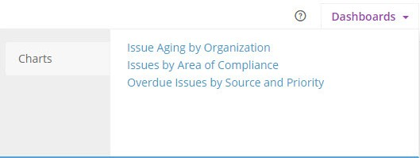

**Figure 34** Dashboards of Overview (Issues)

You can access the following charts:

* + **Issue Aging by Organization**: This chart provides an overview of all remediation issues based on owner organizations and the due dates. It displays the issues that are:
    - Not Due Yet
    - Passed due date in 1-30 days
    - Passed due date in 31-90 days
    - Passed due date above 90 days
  + **Issues by Area of Compliance**: This chart displays the issues classified by related area of compliance. It displays the count of issues that are:
    - Overdue for more than predefined number of days
    - Overdue for more than or equal to predefined number of days
    - Ongoing
  + **Overdue Issues by Source and Priority**: This chart displays the overdue issues that are triggered by various sources - for example, IT-Security.

### Vulnerabilities by Severity

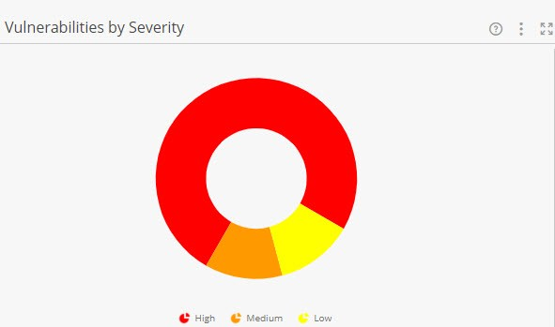

**Figure 35** Vulnerabilities by Severity Chart

|  |
| --- |
| **Description** |
| This pie chart displays the number of vulnerability records based on their severity levels, such as High, Medium, and Low. |
| **Drill down:** |
| **Vulnerabilities** report |

### Vulnerability by Exposure Chart

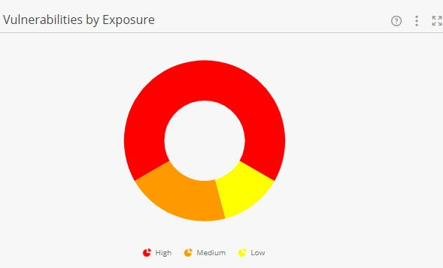

**Figure 36** Vulnerabilities by Exposure Chart

|  |
| --- |
| **Description** |
| This pie chart displays the number of vulnerability records based on their exposure levels, such as High, Medium, and Low. |
| **Drill down:** |
| **Vulnerabilities** report |

### Remediation Issues by Status Chart

**Remediation Issues by Status** is a bar chart. Use this chart to view the remediation issues based on their status.

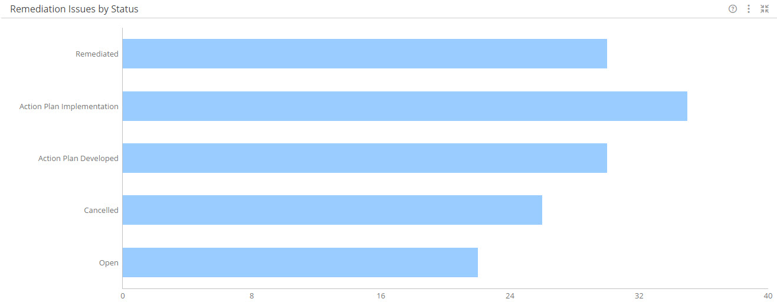

**Figure 37** Remediation Issues by Status Chart

|  |  |
| --- | --- |
| **Description** | **Drill Down** |
| The bar chart illustrates the following:   * **X-axis**: Shows the count of issues. * **Y-axis**: Shows the different status of an issue (Example, Open, Action Plan Implementation, Action Plan Developed). | Remediation Issues report  For more information, see **MetricStream Issues User Guide** Release M7 February 2020. |

### Remediation Issues by Rating Chart

**Remediation Issues by Rating** is a pie chart. Use this chart to view the remediation issues based on their rating.

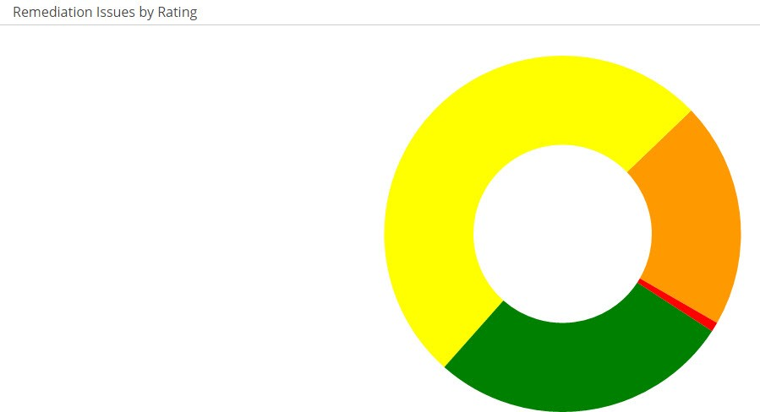

**Figure 38** Remediation Issues by Rating Chart

|  |  |
| --- | --- |
| **Description** | **Drill Down** |
| The pie chart displays the remediation issues of the following ratings:   * Critical * High * Medium * Low | Remediation Issues report  For more information, see **MetricStream Issues User Guide** Release M7 February 2020. |

### Remediation Issues by Priority Chart

**Remediation Issues by Priority** is a bar chart. Use this chart to view the remediation issues based on their priority.

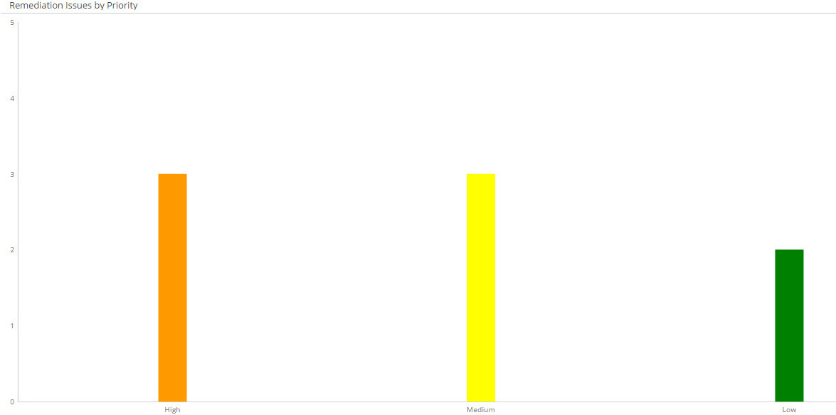

**Figure 39** Remediation Issues by Priority chart

|  |  |
| --- | --- |
| **Description** | **Drill Down** |
| The bar chart illustrates the following:   * **X-axis**: Represents the following Priority levels of the issues:   + High   + Medium   + Low * **Y-axis**: Represents the number of issues for each level | Remediation Issues report  **Note:** For more information, see **MetricStream Issues User Guide** Release M7 February 2020. |

### Remediation Incidents by Status

**Remediation Incidents by Status** is a bar chart. Use this chart to view the Incidents report filtered by the status of the incidents.

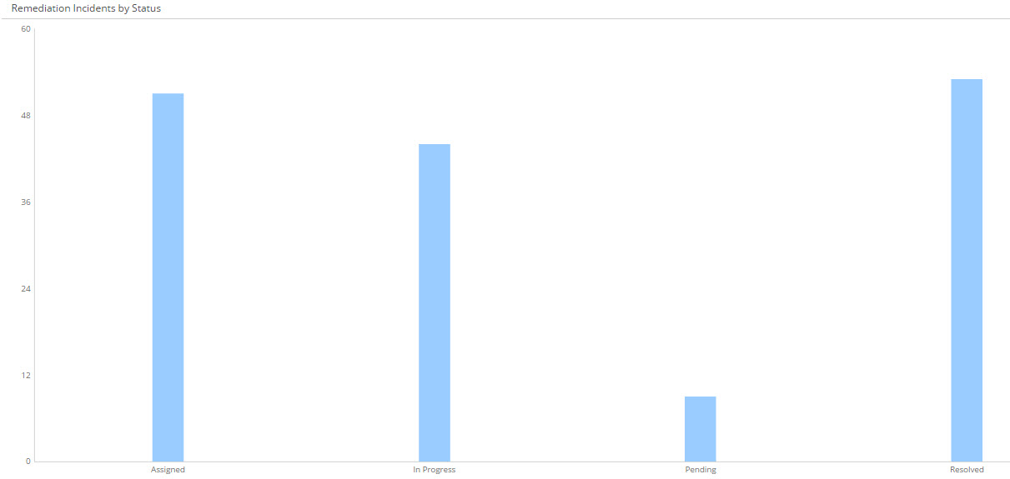

**Figure 40** Remediation Incidents by Status Chart

|  |  |
| --- | --- |
| **Description** | **Drill Down** |
| The bar chart illustrates the following:   * **X-axis**: Shows the status of incidents. * **Y-axis**: Shows the count of incidents. | Remediation Incidents report  For more information, see **MetricStream Issues User Guide** Release M7 February 2020. |

### Remediation Incidents by Impact

**Remediation Incidents by Impact** is a pie chart. Use this chart to view the Incidents report filtered by the impact values of the incidents.

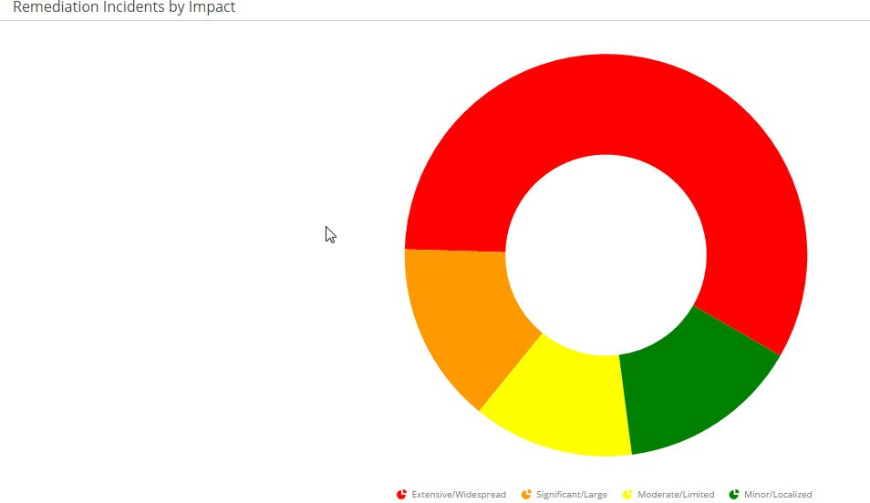

**Figure 41** Remediation Incidents by Impact Chart

|  |  |
| --- | --- |
| **Description** | **Drill Down** |
| The pie chart displays the remediation issues of the following impact values:   * Extensive/Widespread * Significant/Large * Moderate/Limited * Minor/Localized | Remediation Incidents report  For more information, see **MetricStream Issues User Guide** Release M7 February 2020. |

### Remediation Incidents by Urgency

**Remediation Incidents by Urgency** is a bar chart. Use this chart to view the Incidents report filtered by the levels of urgency of the incidents.

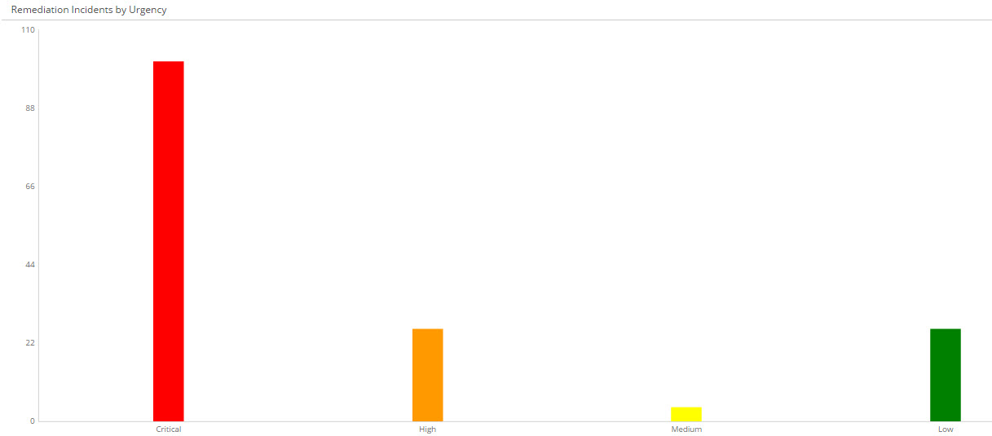

**Figure 42** Remediation Incidents by Urgency Chart

|  |  |
| --- | --- |
| **Description** | **Drill Down** |
| The bar chart illustrates the following:   * **X-axis**: Shows the levels of urgency of incidents. * **Y-axis**: Shows the count of incidents. | Remediation Incidents report  For more information, see **MetricStream Issues User Guide** Release M7 February 2020. |

### Forms

Click **Forms** and then click **Vulnerability** to capture the details of vulnerabilities.

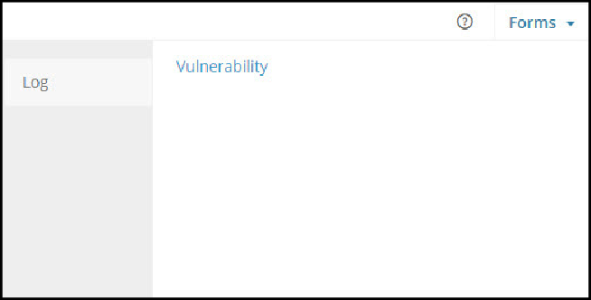

**Figure 43** Vulnerability Forms

|  |  |
| --- | --- |
| **Forms** | **Description** |
| **Vulnerability** | Use this form to capture the details of different vulnerabilities and assess their severity. |

**Note:** For more information on capturing details of vulnerability, refer Managing Vulnerabilities.

### Reports

Click **Reports** and view the required reports related to vulnerabilities.

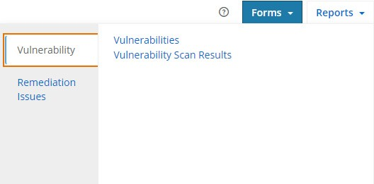

**Figure 44** Vulnerabilities Reports

The following table provides the list of the vulnerabilities related reports. The following table provides the list of the reports.

|  |  |  |
| --- | --- | --- |
| **Navigation** | **Reports** | **Drill-down Reports** |
| From **Vulnerabilities** infocenter, go to **Reports** and click **Vulnerability** | Vulnerabilities | * Related Assets * Related Asset Classes |
| Vulnerability Scan Results | Vulnerability Summary |
| From **Vulnerabilities** infocenter, go to **Reports** and click **Remediation Issues** | Remediation Issues  **Note:** Remediation Issues report is displayed to the users with IT_Risk_Manger role. |  |
| From **Vulnerabilities** infocenter, go to **Reports** and click **Remediation Incidents** | Remediation Incidents  **Note:** Remediation Incident report is displayed to the users with IT_Risk_Analyst role. |  |

**Note:** Users with IT_LOB_Head role can view Vulnerabilities, Vulnerability Scan Results, Remediation Issues and Remediation Incidents reports.

#### Remediation Issues

This is a key report and includes a list of all the remediation issues (both automated and manually triggered) in the system for the following combined risk ratings:

* + Critical
  + High
  + Medium
  + Low

#### Remediation Incidents

This is a key report that displays the list of auto triggered incidents for identified vulnerabilities. The report classifies the incidents based on their combined risk ratings.:

* + Critical
  + High
  + Medium
  + Low

#### Vulnerabilities

|  |
| --- |
| **Use this report to:** |
| View the details of all the available vulnerabilities that are captured manually by the user. |

###### Key Columns

|  |  |
| --- | --- |
| **Column** | **Description** |
| **Name** | Displays the name of the vulnerability. Drill Down: **Vulnerability** form |
| **CVSS Base Score** | Displays the base score of vulnerability based on Common Vulnerability Scoring System (CVSS). |
| **CVSS Temporal** | Displays the temporal score of the vulnerability based on Common Vulnerability Scoring System (CVSS). |
| **Type** | Displays the type of vulnerability. |
| **Category** | Displays the category of vulnerability. |
| **Severity** | Displays the severity level of the vulnerability. |
| **Exposure** | Displays the exposure level of the vulnerability. |
| **Source** | Displays the source of the vulnerability. |
| **Issues** | Displays the number of internal issues captured for vulnerability. |
| **Related to Assets** | Displays the number of assets associated with the vulnerability. Drill Down: Related Assets |
| **Related to Asset Classes** | Displays the number of asset classes associated with the vulnerability. Drill Down: Related Asset Classes. |

#### Vulnerability Scan Results

|  |
| --- |
| **Use this report to:** |
| View the details all the vulnerabilities that are identified through scanner and shows the issues that are triggered based on the remediation rules and the default rules. The report also displays the status for each Issue ID/Incident ID. The vulnerabilities are classified in four types of combined risk ratings. They are:   * Critical * High * Medium * Low. |

**Note:** Click on **Log Issue** / **Create Issue** if you want to manually trigger an Issue/Incident. Manual triggering of issues/incidents is based on configuration parameter.

##### Mandatory Filters

|  |  |
| --- | --- |
| **Filter** | **Description** |
| **Combined Risk Rating** | Select the combined risk rating of vulnerability. |
| **Source** | Select the connectors from which the vulnerability is captured. |
| **Issue/Incident Created?** | Select whether issue/incident for the vulnerability were created or not. |

###### Key Columns

|  |  |
| --- | --- |
| **Column** | **Description** |
| **Combined Risk Rating** | Displays the risk rating of the vulnerability. |
| **Asset Name** | Displays the name of the asset associated with the vulnerability. Move the mouse pointer over this column to view the Hover Card. |
| **Source** | Displays the connector from which the vulnerability is captured. |
| **Vulnerability Summary** | Displays the type of vulnerability. Drill Down: Vulnerability Summary |
| **Type** | Displays the type of vulnerability. |
| **Category** | Displays the category of vulnerability. |
| **CVSS Base Score** | Displays the base score of vulnerability based on Common Vulnerability Scoring System (CVSS). |
| **Issue/Incident ID** | * If issue/incident is created, then Issue/Incident ID is displayed. * If issue/incident is not created, then the Log Incident link is displayed to log an issue or incident. |
| **Issue/Incident Status** | Displays the status of the created issue/incident. |

#### Vulnerability Summary

|  |
| --- |
| **Use this report to:** |
| View the summary of the selected vulnerability scan result. |

###### Key Columns

|  |  |
| --- | --- |
| **Column** | **Description** |
| **Displays** | Displays the description of the vulnerability. |
| **Consequence** | Displays the consequence details that may occur due to the vulnerability. |
| **Solution** | Displays the details of the solution taken to rectify the vulnerability. |
| **CVE IDS** | Displays the CVE ID of the vulnerability. |
| **Severity** | Displays the severity of vulnerability. |

#### Related Assets

|  |
| --- |
| **Use this report to:** |
| This is a drill down report from the **Threats** report and the **Vulnerabilities** report. You can view the name of all the assets associated with the selected threat/vulnerability. |

###### Key Columns

|  |  |
| --- | --- |
| **Column** | **Description** |
| **Name** | Displays the name of the assets associated with the threat/vulnerability. |

#### Related Asset Classes

|  |
| --- |
| **Use this report to:** |
| This is a drill down report from the **Threats** report and the **Vulnerabilities** report. You can view the name of all the asset classes associated with the selected threat/vulnerability. |

###### Key Columns

|  |  |
| --- | --- |
| **Column** | **Description** |
| **Name** | Displays the name of the asset classes associated with the threat/vulnerability. |

### Related Vulnerabilities

|  |
| --- |
| **Use this report to:** |
| This is a drill down report from the **Threats** report and the **Vulnerabilities** report. You can view the name of all the vulnerabilities associated with the selected threat/vulnerability. |

###### Key Columns

|  |  |
| --- | --- |
| **Column** | **Description** |
| **Name** | Displays the name of the vulnerabilities associated with the threat/vulnerability. |

### Related Controls

|  |
| --- |
| **Use this report to:** |
| This is a drill down report from the **Threats** report and the **Vulnerabilities** report. You can view the name of all the controls associated with the selected threat/vulnerability. |

###### Key Columns

|  |  |
| --- | --- |
| **Column** | **Description** |
| **Name** | Displays the name of the controls associated with the threat/vulnerability. |

### Related Risks

|  |
| --- |
| **Use this report to:** |
| This is a drill down report from the **Threats** report and the **Vulnerabilities** report. You can view the name of all the risks associated with the selected threat/vulnerability. |

###### Key Columns

|  |  |
| --- | --- |
| **Column** | **Description** |
| **Name** | Displays the name of the risks associated with the threat/vulnerability. |

### Related Threat

|  |
| --- |
| **Use this report to:** |
| This is a drill down report from the **Threats** report and the **Vulnerabilities** report. You can view the name of all the threat associated with the selected threat/vulnerability. |

###### Key Columns

|  |  |
| --- | --- |
| **Column** | **Description** |
| **Name** | Displays the name of the threat associated with the threat/vulnerability. |

## Libraries

Use the **Libraries** page to manage libraries such as risks, asset, asset classes, processes related to IT- Risk Management. Also, able to structure the IT - Risk Assessment my mapping the Risks to related asset, asset classes and processes as required. View reports related to libraries and modify them. The following **Libraries** page is available for IT - Risk Manager and IT - Risk Analyst. For more information on the role-infocenter/privilege mapping, see Roles, Privileges, and Infocenters.

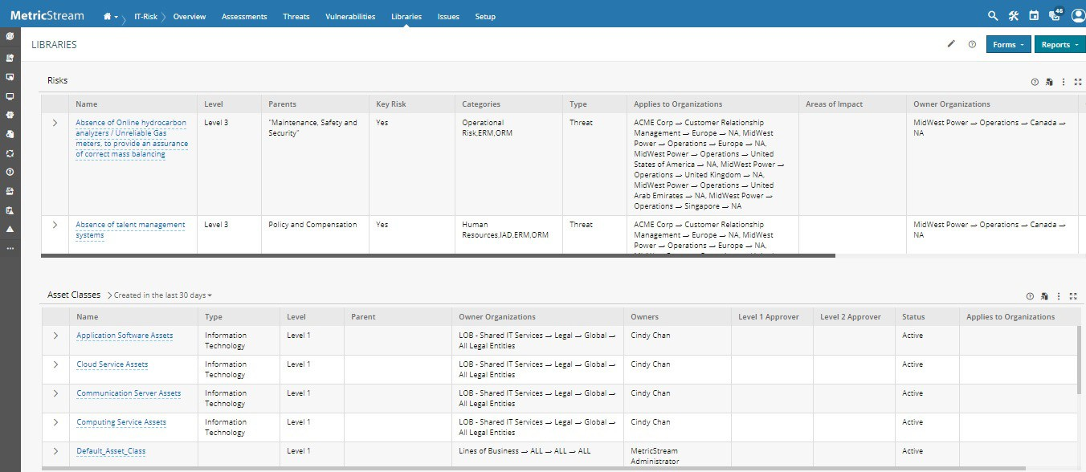

**Figure 45** Libraries Page

### Risks Report

Use the **Risks** report to view the details of all the Risks in the system and manage them.

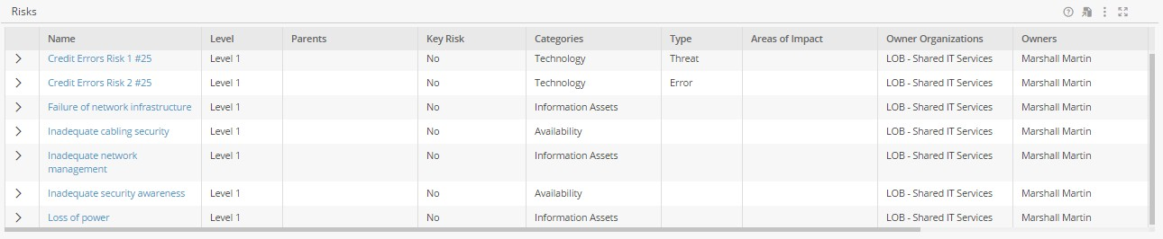

**Figure 46** Risks Report

###### Key Columns:

* + **Name:** Displays the name of the Risk.
    - Drill Down: **Risk** form
  + **Categories:** Displays the category of the Risk.
  + **Parents:** Displays the parent risk.

**Note:** For details, refer to the MetricStream Governance, Risk and Compliance Foundation User Guide Release M7 February 2020.

### Asset Classes

Use Asset Classes report to view details of the active and inactive Asset Classes in the library.

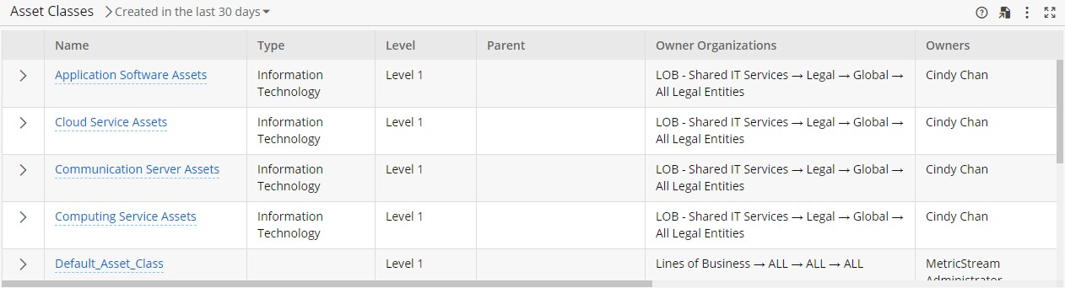

###### Key Columns:

* + **Name**: Displays the Asset Class name. When you move the pointer over the name, the Hover Card appears.
    - Drilled-down: **Asset Class** form.
  + **Level**: Displays the level of the Asset Class.
  + **Parent**: Displays the name of the parent Asset Class. This column remains blank if the hierarchical level of the Asset Class is level 1.
  + **Status**: Displays the status of the Asset Class.

### Forms

Use the links within the **Forms** drop-down list to create the library contents such as Asset, Asset class, Process and so on that are required for conducting the IT - Risk assessments as shown in the following figure.

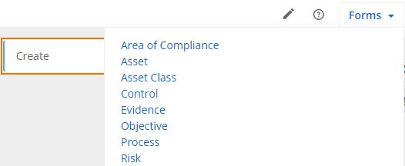

**Figure 47** Forms of Libraries

You can create:

* + **Area of Compliance:** Opens the **Area of Compliance** form. Use this form to document the area of compliances related to IT - Risk such 12 CFR Part 205, Electronic Fund Transfers, COBIT 5, 17 CFR Part 240.15d-15, and so on.
  + **Asset:** Opens the **Asset** form. Use this form to document the assets related to IT.
  + **Asset Class:** Opens the **Asset Class** form. This categorizes the assets based on their features and operational capabilities. It models the business and technical categorization of assets. An asset can belong to one or more asset classes and an asset class can have one or more assets.
  + **Control:** Opens the **Control** form. Define methods, procedures, processes, systems, or software artifacts designed to enforce and reflect the policies, procedures, practices, and organizational structures, which are

required to ensure that the business objectives are achieved, and undesirable events are detected and corrected.

* + **Evidence:** Opens the **Evidence** form. This servers as a single centralized repository for all the documents which can be used during the IT-Risk related activities.
  + **Objective**: Opens the **Objective** form. Use the form to define and create a new objective and also send it for approval.
  + **Process:** Opens the **Process** form. Use this form to document all the processes related to IT asset management.
  + **Risk:** Opens the **Risk** form. Use this form to document the Risk related to IT such as Asset Management Risk, Access Control, Abuse of user right permission and so on.

**Note:** For details, refer to the MetricStream Governance, Risk, and Compliance Foundation User Guide Release M7 February 2020.

### Reports

Use the links within the **Reports** drop-down list to view and modify the library contents such as Asset, Asset class, Process and so on that are required for conducting the IT - Risk assessments as shown in the following figure.

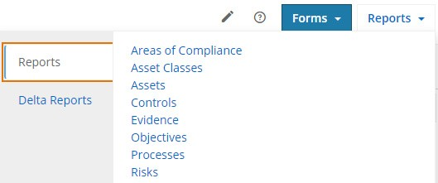

**Figure 48** Reports of Libraries

You can access the following key reports:

* + **Areas of Compliance:** Opens the **Areas of Compliance** report, which displays all the areas of compliance in the application.
  + **Asset Classes:** Opens the **Asset Classes** report, which displays all the asset classes available in the application.
  + **Assets:** Opens the **Assets** report, which displays all the assets available in the application.
  + **Controls:** Opens the **Controls** report, which displays all the controls available in the application.
  + **Evidence:** Opens the **Evidence** report, which displays all the evidences available in the application.
  + **Objectives**: Opens the **Objectives** report, which displays all the objectives available in the application.
  + **Processes:** Opens the **Processes** report, which displays all the processes available in the application.
  + **Risks:** Opens the **Risks** report, which displays all the risks available in the application.

**Note:** For details, refer to the MetricStream Governance, Risk, and Compliance Foundation User Guide Release M7 February 2020.

You can also Access delta reports:

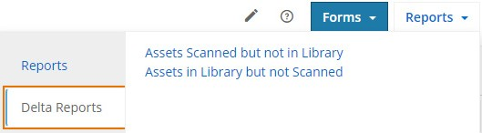

* + **Assets Scanned but not in Library**: This report provides a list of assets scanned by either of the network vulnerability scanners QualysGuard or Nessus or both. These assets are not created in GRC Libraries.
  + **Assets in Library but not Scanned:** This report provides a list of available assets in GRC Libraries. These assets are not scanned by either of the network vulnerability scanners - QualysGuard or Nessus or both.

## Issues

Use the **Issues** page to report an issue, initiate an action to resolve the issue, view different issue/action details. The following **Issues** page is available for IT - Risk Manager, IT - Risk Analyst and It - Risk Assessor. For more information on the role-infocenter/privilege mapping, see Roles, Privileges, and Infocenters.

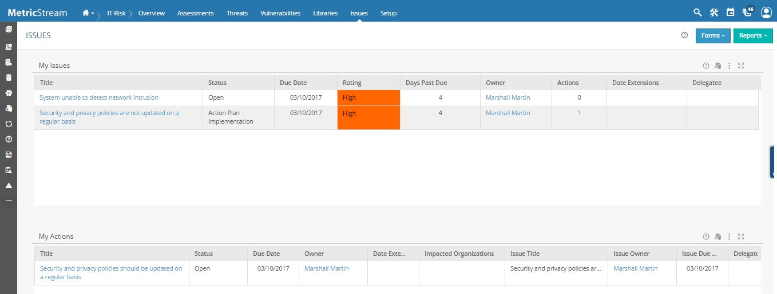

**Figure 49** Issues Page

### My Issues Report

Use the **My Issues** report to view the details of all the issues that you need to manage and monitor. Using this report, you can initiate actions, delegate and so on based on the workflow stage of the issue.

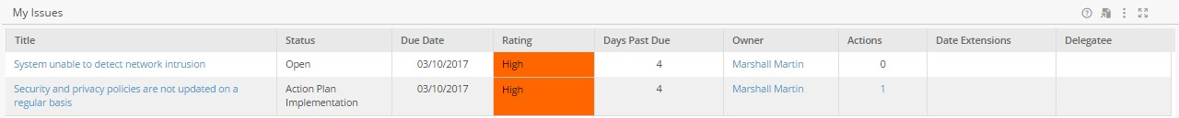

**Figure 50** My Issues Report

###### Key Columns:

* + **Title:** Displays the title of the issue.
    - Drill Down: **Issue** form
  + **Due Date:** Displays the date by when issue needs to be remediated.

### My Actions Report

Use the **My Actions** report to view the list of actions that you need to work on to remediate the issue.



**Figure 51** My Actions Report

###### Key Columns:

* + **Title:** Displays the title of the issue.
    - Drill Down: **Issue** form
  + **Due Date:** Displays the date by when issue needs to be remediated.

**Note:** For details, refer to the MetricStream Issues User Guide Release M7 February 2020.

### Forms

Use the links within the **Forms** drop-down list to log an issue, initiate an action, and auto delegate an issue as shown in the following figure.

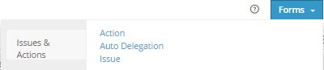

**Figure 52** Forms of Issues & actions

You can access the following forms:

* + **Action:** Opens the **Action** form. Use this form to initiate an action to resolve the issue.
  + **Auto Delegation:** Opens the **Auto Delegation** form. Use this form to delegate the action to a different user.
  + **Issue:** Opens the **Issue** form. Use this form to report an issue.

**Note:** For details, refer to the MetricStream Issues User Guide Release M7 February 2020.

### Reports

Use the links within the **Reports** drop-down list to view and assign issues, as shown in the following figure.

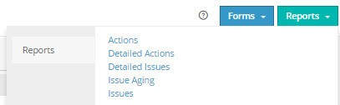

**Figure 53** Reports of Issues

You can access the following reports:

* + **Actions**: Use the **Actions** report to view the details (such as percentage of action completed and date on which the action was closed) of all the action items triggered in the system.
  + **Detailed Actions**: Use the **Detailed Actions** report to view the details (such as status and owner of the action) about all the actions created in the system along with the issue associated with it.
  + **Detailed Issues**: Use the **Detailed Issues** report to view the detailed information (such as status and rating of the issue) about all the issues triggered in the system.
  + **Issue Aging**: Use the **Issue Aging** report to view the aggregated count of issues by the time period. The split by the time period helps the user to identify issues that need immediate attention (issues already overdue) and plan activities for issues that will become overdue soon. This report displays the following:
* Issues that have become overdue in the last 1 month, 1-3 months, beyond 3 months and so on.
* Issues that will become overdue in the next 1 month, 1-3 months, and beyond 3 months.
  + **Issues**: Use the **Issues** report to view the details (such as due date and action associated) of all the issues triggered in the system.

**Note:** For details, refer to the MetricStream Issues User Guide Release M7 February 2020.

## Setup (ITGRC Apps Administrator)

You need to configure this before you can start the setup of IT-Risk Management Framework. Use the Setup page to configure and manage the API users who can create the GRC Libraries - Areas of Compliance, Asset Classes, and Assets.

**Note: ITGRC_Configure_GRC_Libraries_API_Users** activity should be mapped to ITGRC Apps Administrator.

The following Setup page is only available for ITGRC Apps Administrator. For more information on the role- infocenter/privilege mapping, see Roles, Privileges, and Infocenters.

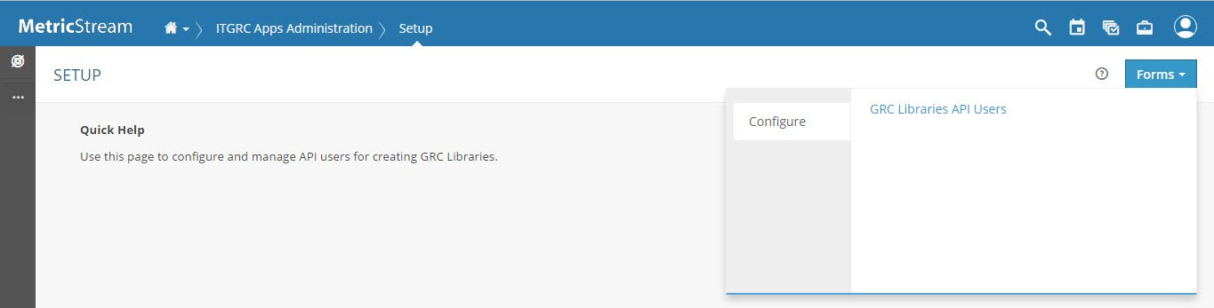

**Figure 54** Setup Page for ITGRC Apps Administrator

### Forms

Use the link within the **Forms** button to access the forms, as illustrated next.

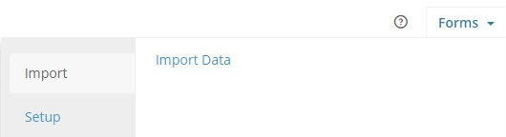

**Figure 55** Forms of Setup

|  |  |
| --- | --- |
| **Forms** | **Description** |
| **Import** |  |
| **Import Data** | Opens the **Import Data** form to upload the library content, Threat Actor, Threat, and Vulnerability details. For more information, refer Uploading Data. |
| **Setup** |  |
| **GRC Libraries API Users** | Opens **GRC Libraries API Users** form. Use this form to configure and manage API users. For more information, refer GRC Libraries API Users Form. |
| **GRC Libraries Relationship Configuration** | Opens **GRC Libraries Relationship Configuration** form. Use this form to configure relationships with GRC library. For more information, refer to the Governance, Risk, and Compliance Intelligence User Guide Release M7 February 2020. |

|  |  |
| --- | --- |
| **Forms** | **Description** |
| **IT-GRC Apps Configuration** | Opens **IT-GRC Apps Configuration** form. Use this form to configure motives of the threat actor, and scale to be used in the **Threat** form. For more information, refer IT-GRC Apps Configuration Form.  You can also capture issue types and asset business criticality. For more information, refer to IT-Compliance Management User Guide Release M7 February 2020. |

#### Uploading Data

You can upload the data directly to the Threat actor, Threat, and Vulnerability forms by downloading an export Excel template, enter the details, and then upload them back.

To upload data:

1. Open the **Data Import Excel Template** report.
2. In the **Template File** column, click the required link (for example, MS_ITS_THREAT_ACTOR.xls) to download the Excel template.
3. Open the template, fill the details, and then save the file.
4. From **Forms**, click **Import** and click **Import Data**. The **Import Data** form appears.
5. From the **Entity** list, select the required (Threat, Threat Actor, or Vulnerability) entity.
6. From the **Profile** list, select the required profile.
7. In the **File to import** field, click  to browse and import the updated file.
8. Click **Submit**.

**Note:** Use the Import Status report to view the details about the recently uploaded data.

#### GRC Libraries API Users Form

You can add new configurations to the list and edit or delete existing configurations with this form. You can configure 5 library options:

* + Area of Compliance
  + Asset
  + Asset Class
  + Process
  + Risk

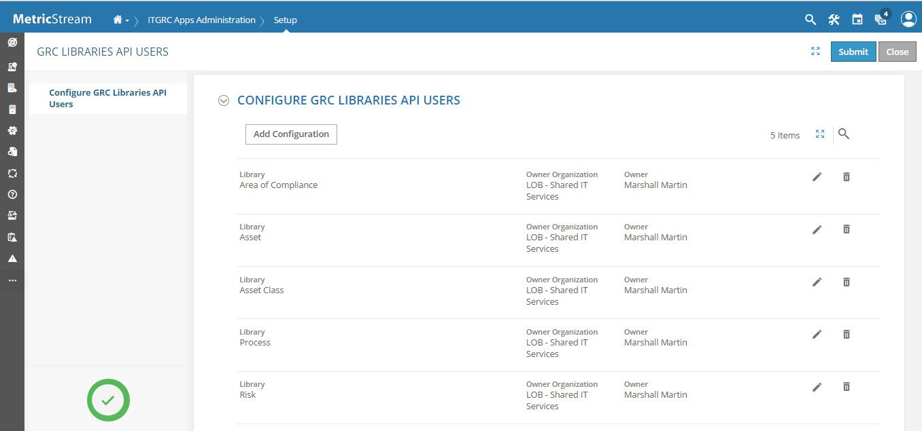

**Figure 56** Configuring GRC Libraries API Users

##### Adding a configuration

To add a new configuration:

1. Click **Add Configuration**.

The **Configuration** window appears.

1. Provide information in the required fields as described in the following table.

|  |  |
| --- | --- |
| **Field** | **Description** |
| **Library** | From the drop-down list, select the required library option. For example, Asset. |

|  |  |
| --- | --- |
| **Field** | **Description** |
| **Owner Organization** | The organization that is responsible for managing the selected library option. To select one or more organizations:   1. Click Add icon associated with the field.   The **Owner Organization** window appears displaying the defined organization structure.   1. Select the required organization structure, and then click **Add**.    1. If you want to add more organization structures in the **Owner Organization** window, select the **Add Another** check box.    2. Select the organization structure that needs to be added, and then click **Add to List**.   After you added all the required organizations, click **Done** to close the Owner Organization window. |
| **Owner** | The users of the selected owner organization, who are responsible for managing the selected library option. The list of users available for selection is based on the selected organization structure. |

1. Click **Done** to confirm the selection.

**Note:** Click **Cancel** to discard the changes.

##### Editing a configuration

To edit an existing configuration:

**Step 1** Click Edit icon. The **Configuration** window appears.

**Step 2** Refer to steps 2 through 7 of Adding a configuration.

##### Deleting a configuration

To delete an existing configuration:

Click Delete icon to delete a configuration.

**Note:** Click Undo icon to undo the deletion.

After completing the changes, click **Submit** to confirm the configuration changes.

#### IT-GRC Apps Configuration Form

The **IT-GRC Apps Configuration** form allows you to configure the details related to IT-Compliance and Threat and Vulnerability.

The **IT-GRC Apps Configuration** form comprises the following sections:

|  |  |
| --- | --- |
| HEADER | Displays the action buttons to take action on the form. |
| IT-COMPLIANCE | Helps you to configure issue types and business criticality rate for assets. For more information, refer IT-Compliance Management User Guide Release M7 February 2020. |
| THREAT AND  VULNERABILITY | Helps you to configure motives of the threat actor and scale to be used in the **Threat**  form. |

To configure details related to Threat and Vulnerability:

1. From **Setup** and click **IT-GRC Apps Configuration**. The **IT-GRC Apps Configuration** form opens.
2. In the **Threat and Vulnerability** section, proceed to configure motives of the threat actor and scale of measurement of threat actor skills.
   1. In the **Configure Motives** subsection, click **Add** to add motives of the threat actor. A row appears.

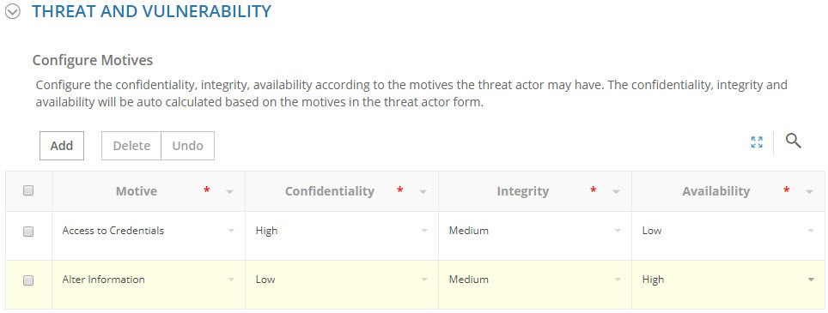

**Figure 57** Configure Motives subsection

* 1. Provide required information in the columns as described in the following table.

|  |  |
| --- | --- |
| **Column** | **Description** |
| **Motive** | The motives of the threat actors. |
| **Confidentiality** | The confidentiality level corresponding to the motive. |
| **Integrity** | The integrity level corresponding to the motive. |
| **Availability** | The availability level corresponding to the motive. |

**Notes:**

* To delete any added motives, select them, and then click **Delete**.
* To retrieve the last deleted motives, click **Undo**.
* The motives configured here is available in the **Motives** field in the **Threat Actor** form. For more information, refer

MetricStream Threat and Vulnerabilities User Guide Release M7 February 2020.

* 1. In the **Configure Scale to be used in the Threat** section, click **Add**. A row appears.

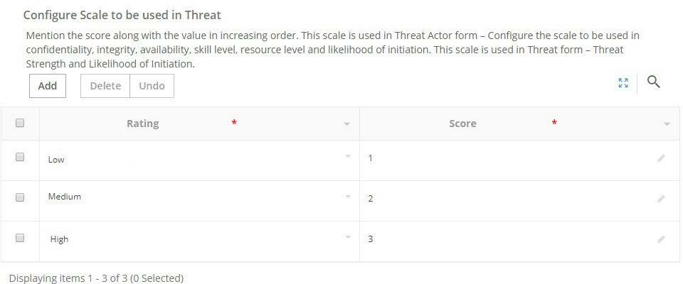

**Figure 58** Configure Scale to be used in Threat subsection

* 1. Provide required information in the columns as described in the following table.

|  |  |
| --- | --- |
| **Column** | **Description** |
| **Rating** | The rating for the skill and resource level associated with the threat actor. |
| **Score** | The score corresponding to the skill and resource level rating. |

**Notes:**

* To delete any added scale, select them, and then click **Delete**.
* To retrieve the last deleted scale, click **Undo**.
* The measurement scale configured for the confidentiality, integrity, availability, skill, and resource levels for the

motives is used in the **Threat Actor** form.

* The configured measurement scale is used for calculating the **Likelihood of Initiation** is used in the **Threat Actor**

form. For more information, refer MetricStream Threat and Vulnerabilities User Guide Release M7 February 2020.

* The configured measurement scale is used in the calculation of **T**hreat Strength is used in the **Threat** form. For more information, refer MetricStream Threat and Vulnerabilities User Guide Release M7 February 2020.
  1. In the **Likelihood of Initiation Calculation** subsection, click **Add**. A row appears.

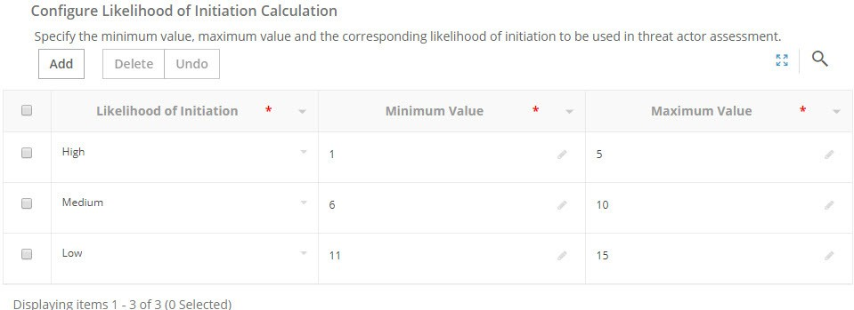

**Figure 59** Configure Likelihood of Initiation Calculation subsection

* 1. Provide required information in the columns as described in the following table.

|  |  |
| --- | --- |
| **Column** | **Description** |
| **Likelihood of Initiation** | The level of likelihood of initiation used in threat actor assessment. |
| **Minimum Value** | The minimum value corresponding to the likelihood of initiation. |
| **Maximum Value** | The maximum value corresponding to the likelihood of initiation. |

**Notes:**

* To delete any added Likelihood of Initiation, select them, and then click **Delete**.
* To retrieve the last deleted Likelihood of Initiation, click **Undo**.
* Based on the configured measurement scale and likelihood of initiation, the **Likelihood of Initiation** of a

**Capability** is calculated. For example, if the selected rating is High and Medium with a score of 1 and 2 respectively, then the Likelihood of Initiation is 1 x 2 = 2 and as 2 is in the range of 1 to 5, the **Likelihood of Initiation** is calculated as **High**.

1. Click **Submit** to save the changes made to the IT-GRC Configuration form.

**Note:** Click **Close** to close the form without saving changes.

##### Editing IT-GRC Apps Configuration

You can edit an existing IT-GRC Apps Configuration, if you have the required privilege.

1. Open the IT-GRC Apps Configuration form from a relevant report.
2. Click **Edit Configuration**.

The IT-GRC Apps Configuration form is opened in the edit mode. For more information, refer IT-GRC Apps Configuration Form.

1. Make the necessary changes, and then perform the required action.

### Reports

Use links within the **Reports** button to access the IT-GRC Apps Configuration report, as displayed in the following figure.

#### GRC Libraries API Users Configuration

|  |
| --- |
| **Use this report to:** |
| View the GRC libraries API users configuration and edit the configuration, if required. For more information on editing the GRC libraries API users Configuration, refer Editing a configuration. |

#### IT-GRC Apps Configuration Report

|  |
| --- |
| **Use this report to:** |
| View the IT-GRC Apps configuration and edit the configuration, if required. For more information on editing the IT-GRC Apps Configuration, refer Editing IT-GRC Apps Configuration. |

## Setup (for other users)

Use the **Setup** page to perform various administrative functions related to IT-Risk management. A quick help is also available for you to set up and manage connectors and the Threat and Vulnerability Management program.

The following **Setup** page is available for IT - Risk Manager and IT - Risk Analyst. For more information on the role- infocenter/privilege mapping, see Roles, Privileges, and Infocenters.

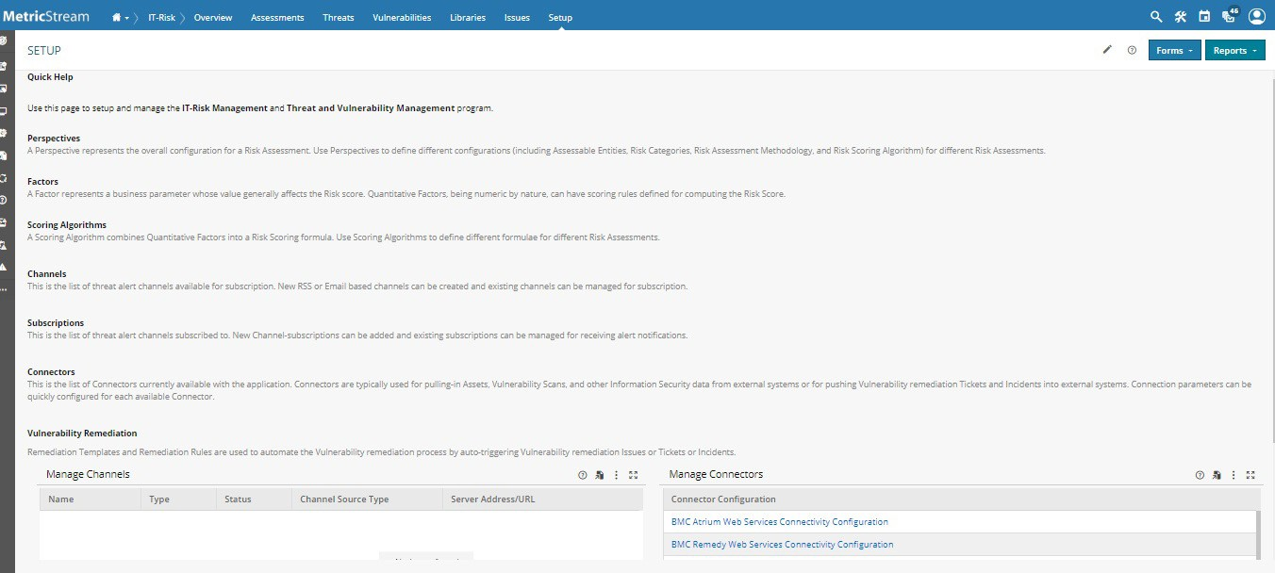

**Figure 60** Setup Page

**Note:** The Setup page provides a brief help text about various features available in the page.

### Forms

Use the links within the **Forms** drop-down list, as shown in the following figure, to access various forms that help in the setting up the app before you begin with the IT- Risk Management assessments.

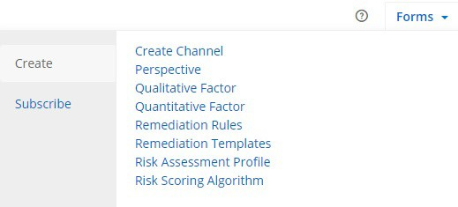

**Figure 61** Forms of Setup Page

You can create:

* **Create Channel:** Opens the **Channel** form. By using this form, you can create threat alert channels. For more information, refer to the Governance, Risk, and Compliance Intelligence User Guide Release M7 February 2020.
* **Perspective:** Opens the **Perspective** form. Perspectives enable organizations to perform various types of risk assessments by using different types of risk scoring algorithms and risk configuration matrix.
* **Qualitative Factor:** Opens the **Qualitative Factor** form. A qualitative factor represents a question, whose responses can be a text, number, date and so on. Use this form to define questions and the corresponding response. The qualitative factors do not carry any weightage.
* **Quantitative Factor:** Opens the **Quantitative Factor** form. Quantitative assessment factors are those factors that are assessed, and the assessment of these factors determines the overall risk score and rating. The two types of quantitative factors are standard and non-standard factors.
* **Remediation Rules:** Opens the **Remediation Rules** form, provides an intuitive rule builder that lets you combine the business context for your assets with the vulnerability context for those assets.
* **Remediation Template:** Opens the **Remediation Templates** form. Use this form to create either remedy template or an issue template to trigger incidents or issues. For more information, refer Remediation Templates.
* **Risk Assessment Profile:** Opens the **Risk Assessment Profile** form, allows you to specify the risk assessment methodology, scoring algorithm, roll-up logic, risk ranges, configuring risk matrix, setting up control assessment, and configuring heat map.
* **Risk Scoring Algorithm:** Opens the **Risk Scoring Algorithm** form, allows you to define the IT-specific risk scoring algorithm based on which the risk assessment is conducted.
* **Channel Subscription:** Opens the **Channel Subscription** form. Use this form to subscribe to the threat alert channels. You can add new channel subscriptions and view the existing channel groups to which you are subscribed. You can add new RSS or email based channels for subscriptions. Additionally, use the **Channel Group Subscriptions** section to create and manage a group of channels.

**Note:** For details, refer to the MetricStream Risk Assessments User Guide Release M7 February 2020.

#### Remediation Templates

The first step of managing your threat and vulnerability management program, is to define remediation templates. These are essentially blueprints for tickets that you want to automatically trigger based on remediation rules (which we will get to shortly). You can choose to manage the tickets using MetricStream's Issues capability or the service desk tool (for example, BMC Remedy) that is already deployed in your organization. These options are described next.

##### Adding Issue Template

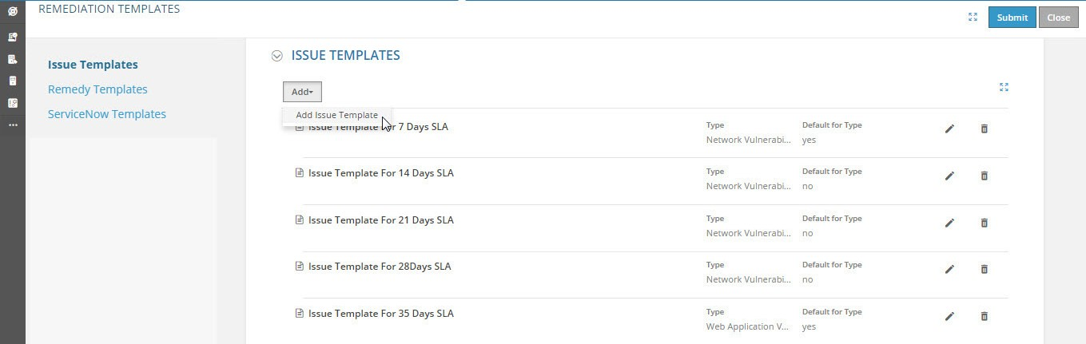

**Figure 62** Adding Issue Template

|  |  |
| --- | --- |
| **Field** | **Description** |
| Click **Add** and click **Add Issue Template** to add a new issue template. | |
| **Name** | Type the name of the issue template. |
| **Type** | Select the type of issue template. The available options are:   * Network Vulnerability Remediation * Web Application Vulnerability Remediation |
| **Default for Type** | Select this check box if you want to mark the current template as default to create an issue manually. |

|  |  |
| --- | --- |
| **Field** | **Description** |
| **Title** | Displays the title of the issue. |
| **Owner Organization** | Select owner organization responsible for maintaining the issue. This field displays the various levels of organizations available to the current user.  To select the owner organization:   1. Click **Add** icon associated with the field.   The **Owner Organization** window appears displaying the defined organization structure.   1. Select the required organization structure, and then click **Add**.   **Note:** See Multidimensional Organization Structure for more details on multidimensional organization structure. |
| **Owner** | Select a user who is responsible for addressing the reported issue. When you submit the form, the selected issue owner receives a task to review the issue. The list of users available for selection is based on the selected organization structure. |
| **Issue Type** | Select the type of the issue. |
| **Due Date** | Type the number of days after which the issue is due. |
| **Issue Approver Section** | |
| **Initial Approver - Organization** | Select the organization to which the initial approver of the issue belongs to.  To select the initial approver organization:   1. Click **Add** icon associated with the field.   The **Initial Approver Organization** window appears displaying the defined organization structure.   1. Select the required organization structure, and then click **Add**.   **Note:** See Multidimensional Organization Structure for more details on multidimensional organization structure. |
| **Initial Approver** | Select the initial approver owner of the issue. The list of users available for selection is based on the selected organization structure. |
| **Action Plan Approver Organization** | Select the organization to which the action plan approver of the issue belongs to.  **Note:** This section will display based on global ISM configuration.  To select the action plan approver organization:   1. Click **Add** icon associated with the field.   The **Action Plan Approver Organization** window appears displaying the defined organization structure.   1. Select the required organization structure, and then click **Add**.   **Note:** See Multidimensional Organization Structure for more details on multidimensional organization structure. |
| **Action Plan Approver** | Select the action plan approver owner of the issue. The list of users available for selection is based on the selected organization structure. For more information, refer Multidimensional Organization Structure. |

|  |  |
| --- | --- |
| **Field** | **Description** |
| **Final Approver Organization** | Select the organization to which the final approver of the issue belongs to. To select the final approver organization:   1. Click **Add** icon associated with the field.   The **Final Approver Organization** window appears displaying the defined organization structure.   1. Select the required organization structure, and then click **Add**.   **Note:** See Multidimensional Organization Structure for more details on multidimensional organization structure. |
| **Final Approver** | Select the final approver owner of the issue. The list of users available for selection is based on the selected organization structure. |

##### Adding Remedy Template

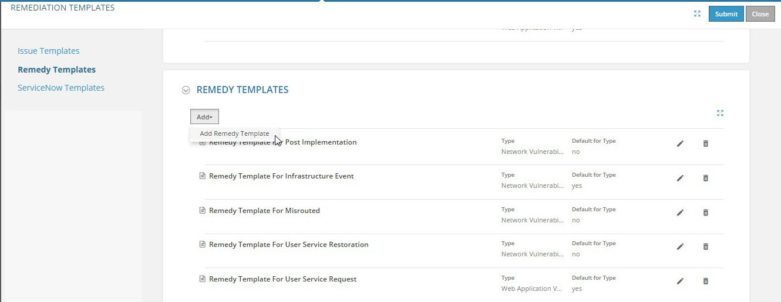

**Figure 63** Adding Remedy Template

|  |  |
| --- | --- |
| **Field** | **Description** |
| From **Add**, click **Add Remedy Template** to add a new Remedy template. | |
| **Name** | Select the remediation template name that you want to add in the rule. |
| **Type** | Select the remediation template type corresponding to the remediation template that you want to add in the rule. The available options are:   * Network Vulnerability Remediation * Web Application Vulnerability Remediation |
| **Default for Type check box** | Select this check box if you want to mark the current template as default to create an incident manually. |

|  |  |
| --- | --- |
| **Field** | **Description** |
| **Service Type** | Select the type of service. This field provides the list of service type values available in BMC remedy. The available options are:   * User Service Restoration * User Service Request * Infrastructure Restoration * Infrastructure Event * Misrouted * Post Implementation |
| **Reported Source** | Select the source from which the remedy incident is reported. This field provides the list of service type values available in BMC remedy. The available options are:   * Direct Input * Email * External Escalation * Fax * Self Service * Systems Management * Phone * Voice Mail * Walk In * Web * Other * BMC Impact Manager Event |
| **Description** | Select vulnerability information for description of remedy incident. The available options are:   * Vulnerability Title * Vulnerability Type * Vulnerability Source * Vulnerability Severity * Vulnerability Category |
| **Detailed Description** | Select detailed vulnerability information for Notes field of the remedy incident. The available options are:   * Vulnerability Title * Vulnerability Type * Vulnerability Description * Vulnerability Source * Vulnerability Severity * Vulnerability Category * Vulnerability Solution * Vulnerability Consequence * CVE Information * CVSS Information |

##### Adding ServiceNow Template

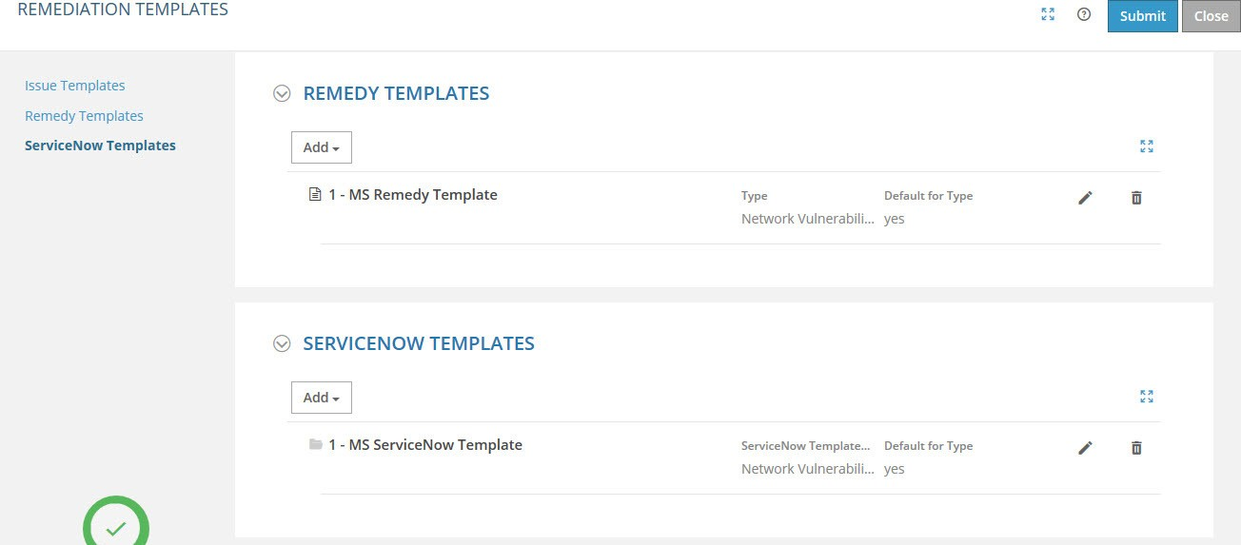

**Figure 64** Adding ServiceNow Templates

|  |  |
| --- | --- |
| **Field** | **Description** |
| From **Add**, click **Add ServiceNow Templates** to add a new ServiceNow template. | |
| **ServiceNow Template Name** | Enter the ServiceNow template name that you want to add in the rule. |
| **ServiceNow Template Type** | Select the type of issue template. The available options are:   * Network Vulnerability Remediation * Web Application Vulnerability Remediation |
| **Default for Type** | Select this check box if you want to mark the current template as default to create an incident manually. |
| **Caller** | Enter the details of the caller who has reported the incident. |
| **Opened By** | Enter the details of the authorized person who has opened the ticket to address the incident. |
| **Contact Type** | Select the type of contact used to report the incident. The available options are:   * Email * Phone * Self-service * Walk-in |
| **Category** | Select the category of the ServiceNow incident. The available options are:   * Request * Inquiry/Help * Software * Hardware * Network * Database |

|  |  |
| --- | --- |
| **Field** | **Description** |
| **Short Description** | Select information for description of incident. The available options are:   * Asset Name * Vulnerability Title |
| **Description** | Select detailed vulnerability information for Notes field of the incident. The available options are:   * Asset Name * IPv4 Address * IPv6 Address * Vulnerability Title * Vulnerability Type * Vulnerability Description * Vulnerability Source * Vulnerability Severity * Vulnerability Category * Vulnerability Solution * Vulnerability Consequence * CVE Information * CVSS Information |

### Reports

Use the links within the **Reports** drop-down list to access respective reports, as shown in the following figure.

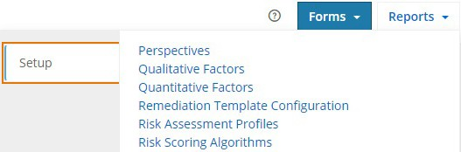

**Figure 65** Reports of Setup page

You can manage:

* **Perspectives:** Opens the Perspectives report, which displays all the published perspectives that are applicable for your organization. It also displays the assessment type and the assessment methodology used for each Perspective.

**Note:** A **Perspective** defines the assessment types (Org-Assessable Item-Risk or Org-Risk or Assessable Item-Risk) and the assessment methodology (Scoring Algorithm / Rating / Scoring and Rating / Scoring Algorithm and Rating / Ranking and Rating) to be used.

* **Qualitative Factors:** Opens the **Qualitative Factors** report, which displays all the published qualitative assessment factors, useful for the risk assessments performed for your organization.

**Note: Qualitative Factors** are usually bunch of questions, the response type of which can be a simple text, date, options such as Yes/No, a paragraph, and so on. The responses to these factors do not directly contribute to the risk score or rating. Instead, these factors help guide the assessor in determining the overall score for the assessment. The qualitative factor responses are typically used for reference, reporting, and documentation purposes.

* **Quantitative Factors:** Opens the **Quantitative Factors** report, which displays all the published quantitative assessment factors, useful for the risk assessments performed for your organization.

**Note: Quantitative Factors** are those factors that are directly assessed and the assessment ratings have a direct effect on the overall risk score and rating. Examples of quantitative factors are DREAD (Damage Potential, Reproducibility, Exploitability, Affected Users, and Discoverability) and STRIDE (Spoofing Identity, Tampering with Data, Repudiation, Information Disclosure, Denial of Service, and Elevation of Privileges).

* **Remediation Template Configuration:** Open the Remediation Template Configuration report, view and edit the configuration, if required. For more information on editing the Remediation Template Configuration, refer Remediation Templates.
* **Risk Assessment Profiles:** Opens the **Risk Assessment Profiles** report, which displays the available risk profiles in the system.
* **Risk Scoring Algorithms:** Opens the **Risk Scoring Algorithms** report, which displays all the defined risk scoring algorithms, useful for the risk assessments performed for your organization.

**Note:** The **Risk Scoring Algorithm** component is used to define the inherent, control, and residual scoring formula. This component supports definition of simple to moderate complex formula. Using the Risk Scoring Algorithm interface, you can define the risk scoring algorithm specific to your organization to conduct risk assessments on a periodic or ongoing basis.

**Note:** For details, refer to the MetricStream Risk Assessments User Guide Release M7 February 2020.

### Managing Connectors Dashboard

The **Managing Connectors** dashboard displays the available connectors which can be used for pulling in vulnerability assessments from external scanning tools.

MetricStream recommends API-based connectivity into vulnerability assessment tools, CMDBs, and service desk or help desk systems. This ensures that the flow of information can be automatically orchestrated by MetricStream across these external systems. For example, asset repositories flow in from CMDBs into the MetricStream application and vulnerability scan data flows in from vulnerability assessment tools into the MetricStream application. Then, prioritized remediation tickets flow out from the MetricStream application into your service or help desk system.

**Note:** The actual connectors available in your environment depends on your subscriptions.

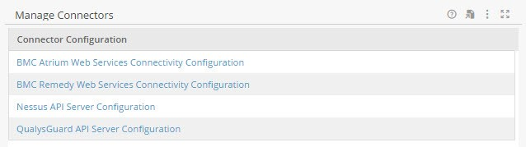

**Figure 66** Manage Connectors Dashboard

You can configure the following connectors through Manage Connectors dashboard:

* BMC Atrium Web Services Connectivity Configuration
* BMC Remedy Web Services Connectivity Configuration
* ServiceNow REST API Configuration (CMDB)
* ServiceNow REST API Configuration (Incidents)
* QualysGuard API Server Configuration
* Nessus API Server Configuration
* Rapid 7 Nexpose API Server Configuration
* Tenable SecurityCenter Configuration

#### BMC Atrium Web Services Connectivity Configuration

Use the BMC Atrium Web Services Connectivity Configuration form to configure web services connection parameters for BMC Atrium. You can configure the connection parameters for BMC Atrium by providing the user credentials in this form.

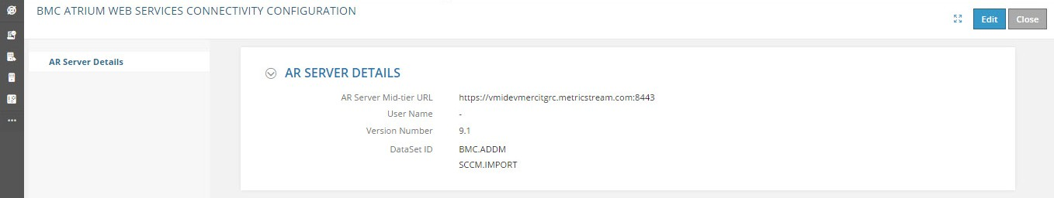

**Figure 67** BMC Atrium Web Services Connectivity Configuration Form

|  |  |
| --- | --- |
| **Field** | **Description** |
| Click **Edit** to modify the form. | |
| **AR Server Mid-tier URL** | Select the mechanism to log into the remedy web service. |
| **User Name** | Type the first name of the remedy user. |
| **Password** | Type the password. |
| **Version Number** | Select the relevant BMC atrium version number. |
| **DataSet ID** | Select the available CMDB dataset ID.  **Note:** This field can be configured based on your requirement. |
| After entering all the required details in the form, click **Submit** to submit the form. | |

##### Running Infolet of BMC Atrium

After submitting the form, you can fetch Asset Classes and Assets from BMC Atrium CMDB into MetricStream GRC libraries by running the related infolets. They are:

###### MS ITG BMC WS FETCH

###### MS_ITG_CMD_CREATE_GRCF_OBJECTS

Once the data is fetched, run the next infolet to update the relationships between the fetched GRC libraries.

###### MS ITG CMD UPDATE GRCF OBJECTS

#### BMC Remedy Web Services Connectivity Configuration

Use the BMC Remedy Web Services Connectivity Configuration form to configure web services connection parameters for BMC Remedy. You can configure the connection parameters for BMC Remedy by providing the user credentials in this form.

After submitting the Configuration Form, create a default Remedy Template in the Remediation Template Form. In the form, set the default Remediation Target as **Remedy**.

**Note:** This form should be configured before setting up Remedy Templates and Rules, for creating incidents into BMC Remedy Management system.

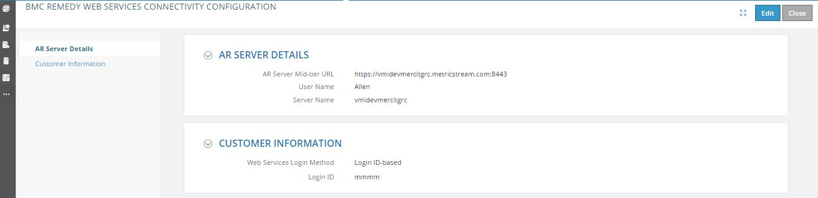

**Figure 68** BMC Remedy Web Services Connectivity Configuration Form

|  |  |
| --- | --- |
| **Field** | **Description** |
| Click **Edit** to modify the form. |  |
| **AR Server Details** |  |
| **AR Server Mid-tier URL** | Type the BMC mid-tier URL. |
| **User Name** | Type the user name. |
| **Password** | Type the password. |
| **Server Name** | Type the host name of the server hosting the BMC remedy. |
| **Customer Information** | |
| **Web Services Login Method** | Select the mechanism to log into the remedy web service. |
| **First Name** | Type the first name of the remedy user. |
| **Middle Initial** | Type the middle name of the remedy server user. |
| **Last Name** | Type the last name of the remedy user. |

After entering all the required details in the form, click **Submit** to submit the form.

##### Running Infolet of BMC Remedy

After submitting the form, setup the remediation templates and rules. Next, run the following infolets:

* MS_ITG_GRC_DATA_PUB_EVENT
* MS_APPSUTILS_PUSH_CIF_EVENT_JOB
* MS_ITS_ITSLP_STATISTICS_INFOLET

Finally, run **MS_ITS_INCIDENT_SCHEDULED_INFOLET** to view the incidents in charts and reports of the App.

#### ServiceNow REST API Configuration (CMDB)

Use the **ServiceNow REST API Configuration (CMBD)** form to configure the ServiceNow setup access to your organization. You should set up the REST API Login Method (Basic Authentication or OAuth2Authentication) and User Name and Password for the ServiceNow (CMDB) API server from which you want to import Asset Classes, Assets, and Business Processes into the MetricStream Foundation Libraries.

After you submit the form:

1. Run the **MS_ITG_SRVC_FETCH_CMDB_DATA** Infolet to fetch the data and import it into the ServiceNow tables.
2. Run **MS_ITG_CMD_CREATE_GRCF_OBJECTS** infolet to import Asset Classes, Assets, and Processes data dynamically into the MetricStream Foundation Libraries.
3. If there are updates to name, type, and so on, run the **MS_ITG_CMD_UPDATE_GRCF_OBJECTS** infolet to fetch the modified data and update the MetricStream Foundation Libraries.

**Figure 69** Servicenow Rest API Configuration (CMDB) Form

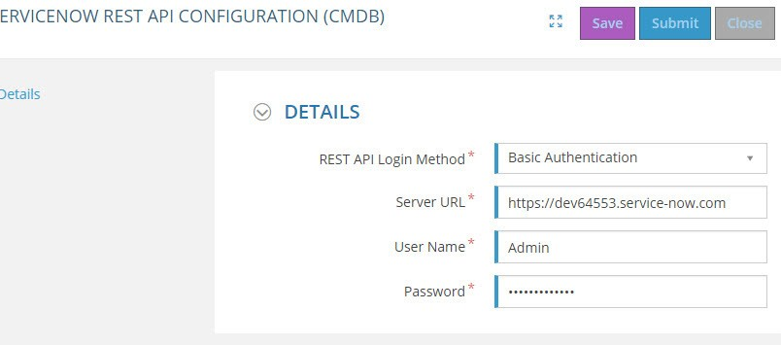

|  |  |
| --- | --- |
| **Field** | **Description** |
| **REST API Login Method** | Select the login method based on your requirement. The following methods are available.   * Basic Authentication * OAuth2 Authentication |
| **Server URL** | Provide the ServiceNow API Server URL. |
| **User Name** | Provide the user name of the ServiceNow. |
| **Password** | Provide the password of the ServiceNow. |

##### Running Infolet of ServiceNow REST API Configuration (CMDB)

After you submit the form:

* + Run the **MS_ITG_SRVC_FETCH_CMDB_DATA** infolet to fetch the data and import it into the ServiceNow tables.
  + Run the **MS_ITG_CMD_CREATE_GRCF_OBJECTS** infolet to import Asset Classes, Assets, and Processes data dynamically into the MetricStream Foundation Libraries.

1. Login as SYSTEMI.
2. Navigate to the **Infolets** page.
3. Click the **Run Infolet** link corresponding to the ServiceNow infolet.

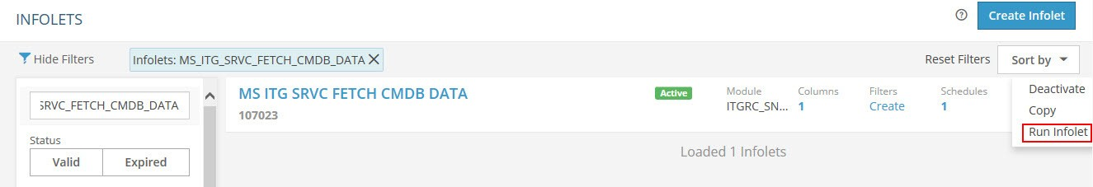

**Figure 70** ServiceNow REST API Configuration (CMDB) Infolet

**Note:** Once you click **Run Infolet**, the data is imported.

#### ServiceNow REST API Configuration (Incidents)

Use the **ServiceNow REST API Configuration (Incidents)** form to configure the ServiceNow setup access to your organization. You should set up the REST API Login Method (Basic Authentication or OAuth2Authentication) and User Name and Password for the ServiceNow (Incidents) API server to trigger Vulnerability Remediation Incidents from MetricStream Security Threat and Vulnerability Management into ServiceNow Incident Management system.

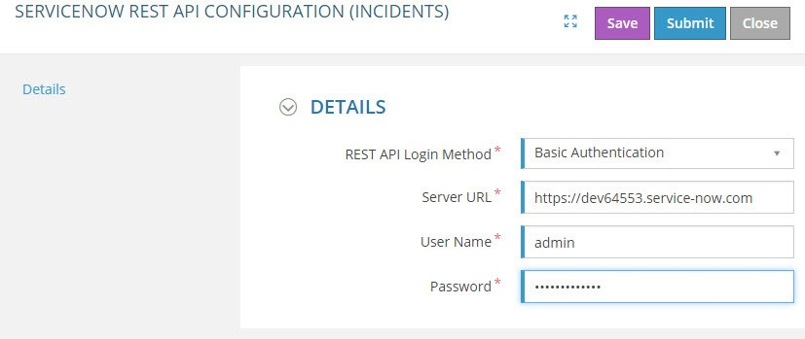

**Figure 71** Servicenow Rest API Configuration (Incidents) Form

|  |  |
| --- | --- |
| **Field** | **Description** |
| **REST API Login Method** | Select the login method based on your requirement. The following methods are available.   * Basic Authentication * OAuth2 Authentication |
| **Server URL** | Provide the ServiceNow API Server URL. |
| **User Name** | Provide the user name of the ServiceNow. |
| **Password** | Provide the password of the ServiceNow. |

##### Triggering Incidents Automatically

After submitting the **ServiceNow REST API Configuration (Incidents)** form, perform the following steps to trigger vulnerability incidents automatically in the Incident management system.

1. From **Setup** page, click **Configure / Setup** and click **Remediation Templates**.
2. Select the **ServiceNow Templates** tab and create a ServiceNow template.
3. Click **Submit**.
4. Navigate to **Setup**, from **Configure / Setup** click **Remediation Rules**.
5. Select the required connector - for example, QualsGuard, Nessus.
6. Define the rule condition to auto trigger incidents to ServiceNow Incident Management system. This rule should be tied the template that is created in the Step 2.

**Note:** Ensure that the **ServiceNow** option is selected in the **Remediation Target**.

1. Click **Submit**.

#### QualysGuard API Server Configuration

By using the **Configure QualysGuard API** Server form, you can configure the QualysGuard connector access to your organization. You should set up the API Server URL, User Name and Password, and Scan List Last Fetch Date for the QualysGuard API server from which you want to retrieve the vulnerability details for the specified duration. Once you submit the form and run the **MS_ITG_QUALYS_SYNC_TAV** infolet, the vulnerability data for the set of assets scanned is retrieved from the QualysGuard server. The retrieved information is saved in the Mongo database.

The TaV related data is saved in the “**MsItgCommonTaV**” collection such as the asset details, related TaV details, scan records, and so on. The Timestamp and the IP addresses of the scanned details are saved in the **MsItgLatestAssetAndLatestTimeStamp** collection.

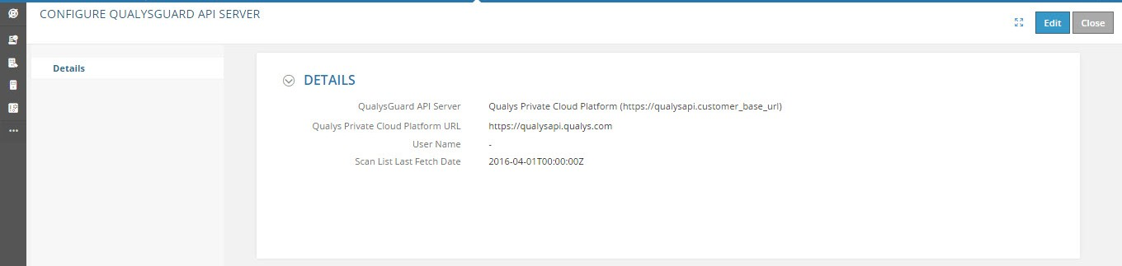

**Figure 72** Configure QualysGuard API Server Form

|  |  |
| --- | --- |
| **Field** | **Description** |
| Click **Edit** icon to modify the form. | |
| **QualysGuard API Server** | Provide the QualysGuard API Server URL. The available options are:   * Qualys US Platform 1 (https://qualysapi.qualys.com) * Qualys US Platform 2 (https://qualysapi.qg2.apps.qualys.com) * Qualys EU Platform (https://qualysapi.qualys.eu) * Qualys Private Cloud Platform (https:// qualysapi.<customer_base_url>) |
| **User Name** | Provide the user name of the QualysGuard API Server. |
| **Password** | Provide the password of the QualysGuard API Server. |

|  |  |
| --- | --- |
| **Field** | **Description** |
| **Scan List Last Fetch Date (YYYY- MMDDTHH:MM:SSZ)** | Provide the duration of the past date that you want to retrieve the scan results. For example, if you want to retrieve the scan results of June 23, 2015 10 AM 10 Minutes and 10 seconds, you can provide input as: **2015-02- 23T10:10:10Z**  **Note:**   * A UI Configuration Parameter is provided for troubleshooting options such as **Download Scanned Host List**, **Check Knowledgebase Status**, and **View API Rate Limit** to QualysGuard server to specify the timestamp from which Scan Results should be pulled into the system. * The details that you have provided for the QualysGuard API Server, User Name,   Password, Scan List Fetch Date are stored in the MS_ITG_Config table. After you submit the form and run the **MS_ITG_QUALYS_SYNC_TAV** infolet, the TaV data is fetched.  For more information on running the infolet, see Running Infolet of QualysGuard. |
| **Test Connection** | Test the connection with QualysGuard API server.  The message “**Connection successful. Please continue**.” appears on successful connection. |
| **Download Scanned Host List**  (*appears if the* ***Test Connection*** *is successful)* | You can download the CSV file that contain the list of assets scanned along with IPv4 addresses.  Perform these steps to configure this option:   1. Click **Settings** icon, click **Configuration and** select **Parameter Category**, to open the list of parameter categories. 2. Type **MS_ITG_QG_API_CALLS** in the search field. 3. Click the parameter category. 4. Select **Yes** in **Editable** field, in **Basic Information** section. 5. Click **Save Changes**. |
| **Check Knowledgebase Status**  (*appears if the Test Connection is successful)* | You can view the status of knowledge base.  **Note:** Ensure that the status is **Active**, to retrieve the Scanned Summary onto Mongo database. |
| **View API Rate Limit**  (*appears if the Test Connection is successful)* | You can view the number of APIs allowed per day.  **Note:** Minimum Remaining Rate limit should be 60-80. Only then scanned summary will be retrieved onto Mongo Data base. |

After entering all the required details in the form, click **Submit** to submit the form.

**Notes:**

* + If any mandatory field remains blank in the Configure QualysGuard API Server form, an error massage displays as ‘**Please provide details for all required fields**’.
  + If any mandatory field value is incorrect in the Configure QualysGuard API Server form, an error massage displays

as ‘**Connection failed. Error: 401 Unauthorized. Please check provided details**’.

##### Running Infolet of QualysGuard

After submitting the form, you can fetch the TaV data from QualysGuard by running the

**MS_ITG_QUALYS_SYNC_TAV** infolet.

The system administrator performs the following steps to retrieve the TaV data from QualysGuard:

1. Login as SYSTEMI.
2. Navigate to the **Infolets** page.
3. Click the **Run Infolet** link corresponding to the **MS ITG QUALYS SYNC TAV** infolet.

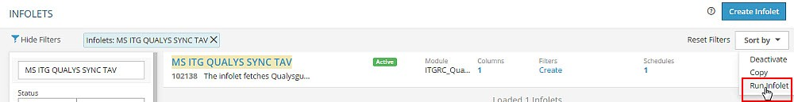

**Figure 73** Running QualysGuard Infolet

**Note:** Once you click **Run Infolet**, the retrieved data from QualysGuard is stored in the MsItgCommonTaV collection.

#### Setting up Remediation Templates - QualysGuard Connector

The first step of managing your threat and vulnerability management program, is to define remediation templates. For setting up templates, refer Remediation Templates.

**Note:** The **Remedy** template and **ServiceNow** template is available in your environment based on your subscription.

##### Adding Remediation Rules - QualysGuard Connector

After configuring your remediation templates, you need to setup business rules that helps you to prioritize the vulnerabilities to be remediated. The App provides an intuitive rule builder that lets you combine the business context for your assets with the vulnerability context for those assets. A remediation rule (when to trigger the ticket), then ties to a remediation target (where to trigger the ticket) and a remediation template (to whom, to trigger the ticket).

The following rules have been set up for the QualysGuard connector:

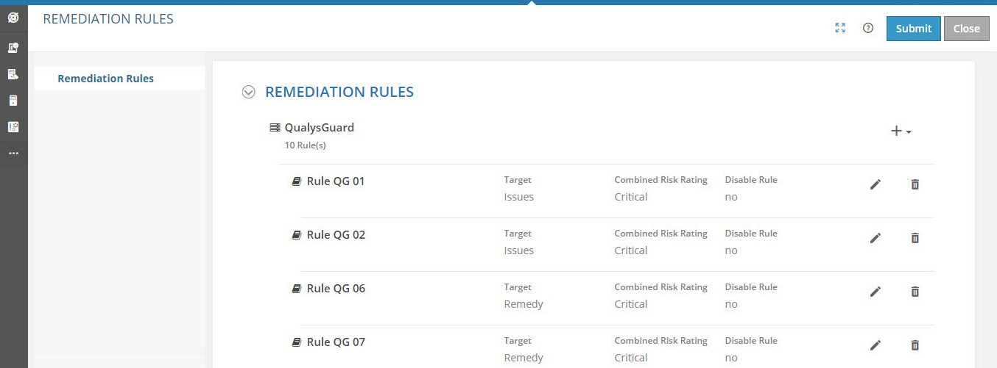

**Figure 74** Adding Remediation Rules - QualysGuard

|  |  |  |
| --- | --- | --- |
| **Field** | **Description** | |
| Click + icon to add new remediation rules | | |
| **Remediation Action** |  |  |
| **Name** | Type the name of the rule. | |
| **Disable Rule check box** | Select this check box if you do not want to apply the defined rule to create issues or incidents. | |
| **Condition** | Displays the rule that is added by using the Rule Expression Wizard window. | |
| **Rule Expression Wizard** | Click this button to define remediation rules for issues or incidents. To define rules, perform the following steps:  **1.** Click the **Rule Expression Wizard** button.  The **Rule Expression Wizard - QualysGuard** window appears. | |
| displays Rule Expression Wizard - QualysGuard window |  |
| 1. Define the rule as required. 2. Click **Submit** to create the rule.   For more information on Rule Expression Wizard - QualysGuard window, see Rule Expression Wizard - QualysGuard Window. | |

|  |  |
| --- | --- |
| **Field** | **Description** |
| **Combined Risk Rating** | Select the combined risk rating. The available options are:   * Critical * High * Medium * Low |
| **Target** | Select the remediation target. Remediation target defines the target system for issue/incident.   * **Issues**: Select this option if you want to trigger issues in the Issues module.   **Note:** You can select remediation target for manual issue/incident creation by configuring the parameter **MS_ITG_RMD_CONFIG**.   * **Remedy**: Select this option if you want to trigger incident in BMC remedy. |
| **Template Type** | Select the remediation template type corresponding to the remediation template that you want to add in the rule. The available options are:   * Network Vulnerability Remediation * Web Application Vulnerability Remediation |
| **Template Name** | Select the remediation template name that you want to add in the rule.  **Note:** Template names are available for selection based on the selected template type. |
| **Incident Priority**  **Appears only when you select Remedy in the Remediation Target field.** | **Urgency**: Select the urgency of the incident. The available options are:   * 1-Critical * 2-High * 3-Medium * 4-Low   **Impact**: Select the impact of the incident. The available options are:   * 1-Extensive/Widespread * 2-Significant/Large * 3-Moderate/Limited * 4-Minor/Localized |

##### Rule Expression Wizard - QualysGuard Window

Use this window to define remediation issue creation rules.

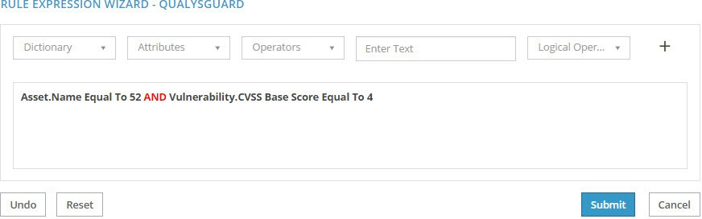

**Figure 75** Rule Expression Wizard - QualysGuard Window

|  |  |
| --- | --- |
| **Field** | **Description** |
| **Dictionary** | Select if you want to create a rule for an Asset or Vulnerability. |
| **Attributes** | Select the attribute for which you want to create the rule. This field displays the values based on the value that you select in the Dictionary field. |
| **Operator** | Select the operator. This field displays the operators based on the values that you select in the Dictionary and Attributes fields.  The available options are:   * Equal To * Not Equal To * Greater Than * Less Than * Greater Than Equal To * Less Than Equal To |
| **Value** | Define the value in this field. This field displays the values based on the attribute that you select in the Attributes field. |
| **Add icon** | Click this icon to add the rule. |
| **Connecting Operator** | Select the connecting operator. The available operators are:   * **AND**: Select this option to “AND” (combine) two different rules. * **OR**: Select this option to “OR” (either of the options) two different rules. |
| **ADD button** | Click this button to add the connecting operator. |
| **Buttons** | |
| **Submit** | Click this button to submit the created rule and close.  Once you submit, the created rule appears in the Rule Condition field of the Remediation Rules form. |
| **Undo** | Click this button to clear the last-entered expression. |
| **Reset** | Click this button to clear the defined rule and reset. |

#### Nessus API Server Configuration

Use the **Configure Nessus API Server** form to configure the Nessus connector. You should set up the API Server URL, User Name and Password for the Nessus API server from which you want to retrieve the vulnerability details for the specified duration. Once you submit the form and run the **MS ITG NESSUS SYNC TAV** infolet, the identified vulnerability data for the set of assets scanned is retrieved from the Nessus server. The retrieved information is saved in the Mongo database.

The TaV related data such as the asset details and related vulnerability details, scan records, and so on are saved in the “**MsItgCommonTaV**” collection. The Timestamp and the IP addresses of the scanned details are saved in the **MsItgLatestAssetAndLatestTimeStamp** collection.

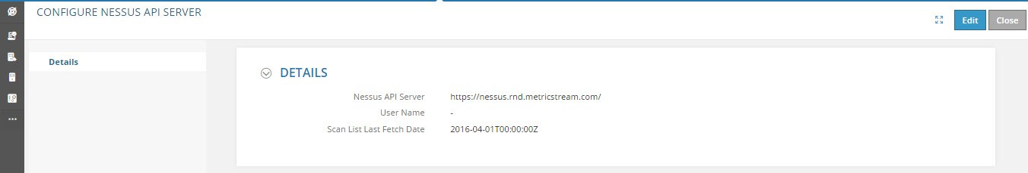

**Figure 76** Configure Nessus API Server Form

|  |  |
| --- | --- |
| **Field** | **Description** |
| Click **Edit** icon to modify the form. | |
| **Nessus API Server** | Type the Nessus API Server URL. |
| **User Name** | Type the user name of the Nessus API Server. |
| **Password** | Type the password of the Nessus API Server. |
| **Scan List Last Fetch Date(YYYY-MMDDTHH: MM:SSZ)** | Provide the duration of the past date that you want to retrieve the scan results. For example, if you want to retrieve the scan results of June 23, 2016 10 AM 10 Minutes and 10 seconds, you can provide input as: **2016-02-23T10:10:10Z**  **Note:** The details that you have provided for the Nessus API Server, User Name, Password, Scan List Fetch Date are stored in the **MS_ITG_Config** table. After you submit the form and run the **MS ITG NESSUS SYNC TAV** infolet, the TaV data is fetched.  For more information on running the infolet, see Running Infolet Nessus. |
| **Test Connection to Nessus API Server** | Test the connection with Nessus API Server.  The message “**Connection successful. Please continue.**” appears on successful connection. |

After entering all the required details in the form, click **Submit** to submit the form.

##### Running Infolet Nessus

After submitting the form, you can fetch the TaV data from Nessus by running the **MS ITG NESSUS SYNC TAV**

infolet.

The system administrator performs the following steps to retrieve the TaV data from Nessus:

1. Login as SYSTEMI.
2. Navigate to the **Infolets** page.
3. Click the **Run Infolet** link corresponding to the **MS ITG NESSUS SYNC TAV** infolet.

**Figure 77** Running the TaV data from Nessus Infolet

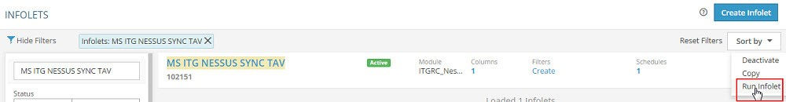

**Note:** Once you click **Run Infolet**, the retrieved data from Nessus is stored in the **MsItgCommonTaV** collection.

##### Setting up Remediation Templates - Nessus Connector

The first step of managing your threat and vulnerability management program, is to define remediation templates. For setting up remediation templates, refer Remediation Templates.

**Note:** The **Remedy** template and **ServiceNow** template is available in your environment based on your subscription.

##### Adding Remediation Rules - Nessus Connector

After configuring your remediation templates, you need to setup business rules that helps you to prioritize the vulnerabilities to be remediated. The App provides an intuitive rule builder that lets you combine the business context for your assets with the vulnerability context for those assets. A remediation rule (when to trigger the ticket), then ties to a remediation target (where to trigger the ticket) and a remediation template (to whom, to trigger the ticket).

The following rules have been set up for the Nessus connector:

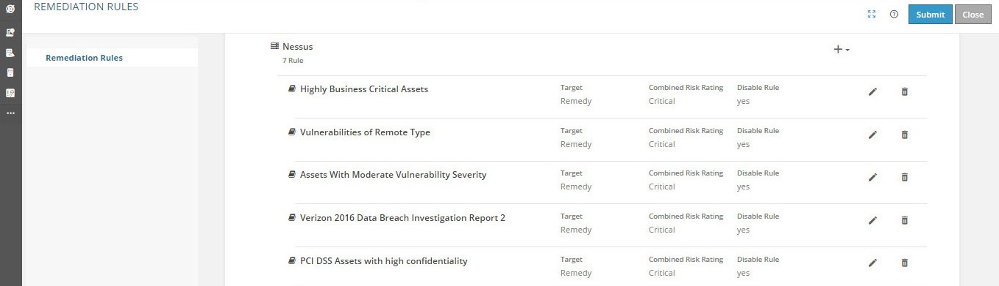

**Figure 78** Adding Remediation Rules - Nessus

|  |  |
| --- | --- |
| **Field/Button Name** | **Description** |
| Click + icon to add new remediation rules | |
| **Remediation Action** |  |

|  |  |
| --- | --- |
| **Field/Button Name** | **Description** |
| **Name** | Type the name of the rule. |
| **Disable Rule check box** | Select this check box if you do not want to apply the defined rule to create issues or incidents. |
| **Condition** | Displays the rule that is added by using the Rule Expression Wizard window. |
| **Rule Expression Wizard button** | Click this button to define remediation rules for issues or incidents. To define rules, perform the following steps:   1. Click the **Rule Expression Wizard** button.   The **Rule Expression Wizard - Nessus** window appears.  Define the rule as required.   1. Click **Submit** to create the rule.   For more information on Rule Expression Wizard - Nessus window, see Rule  Expression Wizard - Nessus Window. |
| **Combined Risk Rating** | Select the combined risk rating. The available options are:   * Critical * High * Medium * Low |
| **Target** | Select the remediation target. Remediation target defines the target system for issue.   * **Issues**: Select this option if you want to trigger issues in the Issues module.   **Note:** You can select remediation target for manual issue creation by configuring the parameter **MS_ITG_RMD_CONFIG**.   * **Remedy**: Select this option if you want to trigger issues in BMC remedy. |
| **Template Type** | Select the remediation template type corresponding to the remediation template that you want to add in the rule. The available options are:   * Network Vulnerability Remediation * Web Application Vulnerability Remediation |

|  |  |
| --- | --- |
| **Field/Button Name** | **Description** |
| **Template Name** | Select the remediation template name that you want to add in the rule.  **Note:** Template names are available for selection based on the selected template type. |
| **Incident Priority**  *(Appears only when you select* ***Remedy*** *in the Remediation Target field.)* | **Urgency**: Select the urgency of the incident. The available options are:   * 1-Critical * 2-High * 3-Medium * 4-Low   **Impact**: Select the impact of the incident. The following options are available:   * 1-Extensive/Widespread * 2-Significant/Large * 3-Moderate/Limited * 4-Minor/Localized |

##### Rule Expression Wizard - Nessus Window

Use this window to define remediation issue creation rules.

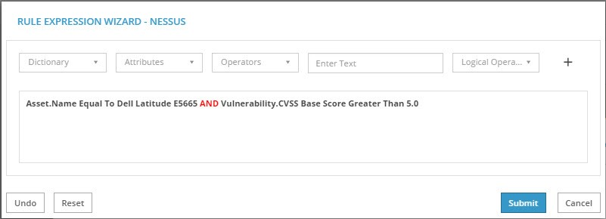

**Figure 79** Rule Expression Wizard - Nessus Window

|  |  |
| --- | --- |
| **Field Name** | **Description** |
| **Dictionary** | Select if you want to create a rule for an **Asset** or **Vulnerability**. |
| **Attributes** | Select the attribute for which you want to create the rule. This field displays the values based on the value that you select in the Dictionary field. |

|  |  |
| --- | --- |
| **Field Name** | **Description** |
| **Operators** | Select the operator. This field displays the operators based on the values that you select in the Dictionary and Attributes fields. The available options are:   * Equal To * Not Equal To * Greater Than * Less Than * Greater Than Equal To * Less Than Equal To |
| **Value** | Define the value in this field. This field displays the values based on the attribute that you select in the **Attributes** field.  **Note:** For attributes like Asset Business Criticality, CIA, Location, Type and Vulnerability Severity, Category, Type value gets auto-populated. |
| **Add icon** | Click this icon to add the rule. |
| **Connecting Operator** | Select the connecting operator. The following operators are available:   * **AND**: Select this option to “AND” (combine) two different rules. * **OR**: Select this option to “OR” (either of the options) two different rules. |
| **ADD** | Click this button to add the connecting operator. |
| **Buttons** | |
| **Submit** | Click this button to submit the created rule and close.  Once you submit, the created rule appears in the Rule Condition field of the Remediation Rules form. |
| **Undo** | Click this button to clear the last-entered expression. |
| **Reset** | Click this button to clear the defined rule and reset. |

#### Rapid 7 Nexpose API Server Configuration

Use the **Rapid7 Nexpose API Server Configuration** form to configure the Rapid7 Nexpose setup access to your organization. You should set up the API Server URL, User Name, and Password for the Rapid7 Nexpose API server from which you want to retrieve the vulnerability details, for the assets scanned through Rapid7 Nexpose for the specified duration. After you submit the form and run the **MS_ITX_NEXPOSE_SYNC_REPORT** infolet, the vulnerability data is retrieved from the Rapid7 Nexpose sever. The retrieved information is saved in the Mongo database. The vulnerability data, such as the scanned asset details and related vulnerability information, and scan records, is saved in the **“MsItgCommonTaV”** collection. The Timestamp and the IP addresses of the scanned assets are saved in the **MsItgLatestAssetAndLatestTimeStamp** collection.

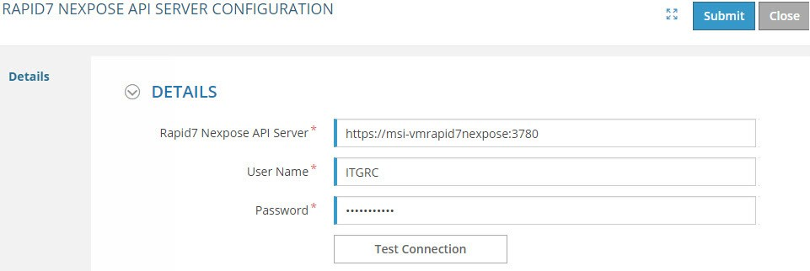

**Figure 80** Rapid 7 Nexpose API Server Configuration Form

|  |  |
| --- | --- |
| **Field** | **Description** |
| **Rapid7 Nexpose API Server** | Type the Rapid7 Nexpose API Server URL. |
| **User Name** | Type the user name of the Rapid7 Nexpose API Server. |
| **Password** | Type the password of the Rapid7 Nexpose API Server. |
| **Test Connection** | Click **Test Connection** to test the connection between the app and Rapid7 Nexpose API Server. If the connection is successful, then a successful message is displayed before proceeding to fetch the scan data. If the connection is not successful, then an error message is displayed. |

After entering all the required details in the form, click **Submit** to submit the form.

##### Running Infolet of Rapid 7 Nexpose

After submitting the form, you can fetch the vulnerability data from Rapid7 Nexpose by running the

**MS_ITX_NEXPOSE_SYNC_REPORT** infolet.

To retrieve the vulnerability data from Rapid7 Nexpose by running the infolet, perform the following:

1. Login as SYSTEMI.
2. Navigate to the **Infolets** page.
3. Click the **Run Infolet** link corresponding to the **MS_ITX_NEXPOSE_SYNC_REPORT** infolet.

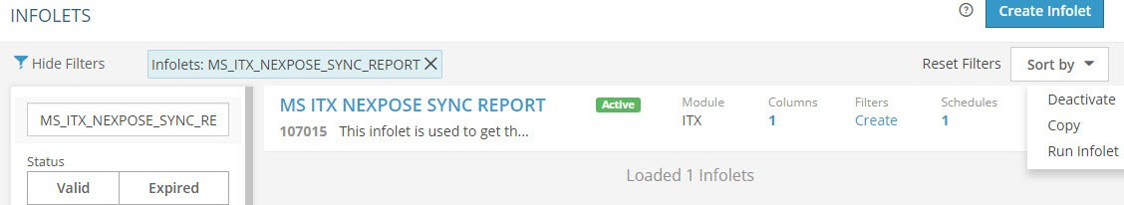

**Figure 81** Running Rapid 7 Nexpose Infolet

**Note:** Once you click **Run Infolet**, the retrieved data from Rapid 7 Nexpose is stored in the **MsItgCommonTaV** collection.

##### Setting up Remediation Templates - Rapid 7 Nexpose Connector

The first step of managing your threat and vulnerability management program, is to define remediation templates. For setting up template, refer Remediation Templates.

**Note:** The **Remedy** template and **ServiceNow** template is available in your environment based on your subscription.

##### Adding Remediation Rules - Rapid 7 Nexpose Connector

After configuring your remediation templates, you need to setup business rules that helps you to prioritize the vulnerabilities to be remediated. The App provides an intuitive rule builder that lets you combine the business context for your assets with the vulnerability context for those assets. A remediation rule (when to trigger the ticket), then ties to a remediation target (where to trigger the ticket) and a remediation template (to whom, to trigger the ticket).

The following rules have been set up for the Rapid 7 Nexpose connector:

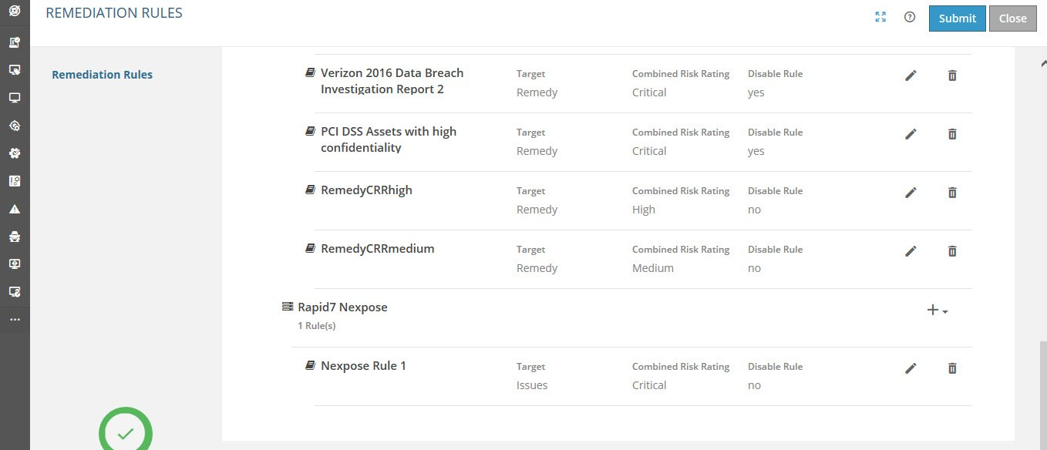

**Figure 82** Adding Remediation Rules - Rapid 7 Nexpose Connector

|  |  |
| --- | --- |
| **Field** | **Description** |
| Click + icon to add new remediation rules | |
| **Remediation Action** |  |
| **Name** | Type the name of the rule. |
| **Disable Rule** | Select the check box if you do not want to apply the defined rule to create issues or incidents. |
| **Condition** | Displays the rule that is added by using the Rule Expression Wizard window. |

|  |  |
| --- | --- |
| **Field** | **Description** |
| **Rule Expression Wizard** | Click this button to define remediation rules for issues or incidents. To define rules, perform the following steps:   1. Click the **Rule Expression Wizard** button.   The **Rule Expression Wizard - Rapid7 Nexpose** window appears.   1. Define the rule as required. 2. Click **Submit** to create the rule.   For more information on **Rule Expression Wizard - Rapid7 Nexpose**  window, see Rule Expression Wizard - Tenable SecurityCenter Window. |
| **Combined Risk Rating** | Select the combined risk rating. The available options are:   * Critical * High * Medium * Low |
| **Target** | Select the remediation target. Remediation target defines the target system for issue/incident.   * **Issues**: Select this option if you want to trigger issues in the Issues module.   **Note:** You can select remediation target for manual issue/incident creation by configuring the parameter **MS_ITG_RMD_CONFIG**.   * **Remedy**: Select this option if you want to trigger incident in BMC remedy. * **ServiceNow:** Select this option if you want to trigger incident in ServiceNow. |
| **Template Type** | Select the remediation template type corresponding to the remediation template that you want to add in the rule. The available options are:   * Network Vulnerability Remediation * Web Application Vulnerability Remediation |
| **Template Name** | Select the remediation template name that you want to add in the rule.  **Note:** Template names are available for selection based on the selected template type. |

|  |  |
| --- | --- |
| **Field** | **Description** |
| **Incident Priority**  *Appears only when you select the Remedy option in the Remediation Target field.* | **Urgency**: Select the urgency of the incident. The available options are:   * 1-Critical * 2-High * 3-Medium * 4-Low   **Impact**: Select the impact of the incident. The available options are:   * 1-Extensive/Widespread * 2-Significant/Large * 3-Moderate/Limited * 4-Minor/Localized |

##### Rule Expression Wizard - Rapid7 Nexpose Window

Use this window to define remediation issue creation rules.

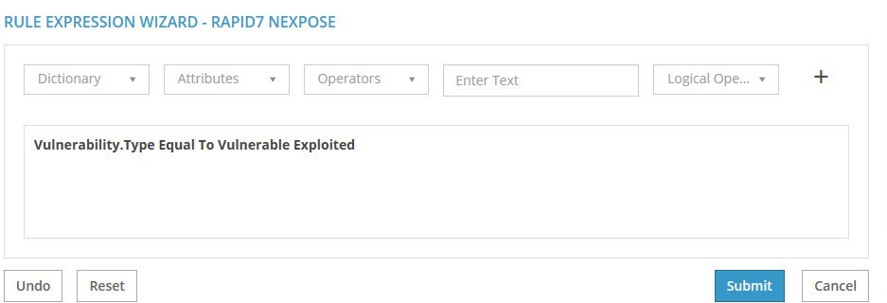

**Figure 83** Rule Expression Wizard - Rapid7 Nexpose Window

|  |  |
| --- | --- |
| **Field** | **Description** |
| **Dictionary** | Select if you want to create a rule for an Asset or Vulnerability. |
| **Attributes** | Select the attribute for which you want to create the rule. This field displays the values based on the value that you select in the Dictionary field. |
| **Operators** | Select the operator. This field displays the operators based on the values that you select in the Dictionary and Attributes fields.  The available options are:   * Equal To * Not Equal To * Greater Than * Less Than * Greater Than Equal To * Less Than Equal To |
| **Value** | Define the value in this field. This field displays the values based on the attribute that you select in the Attributes field. |
| **Add icon** | Click this icon to add the rule. |
| **Connecting Operator** | Select the connecting operator. The available operators are:   * **AND**: Select this option to “AND” (combine) two different rules. * **OR**: Select this option to “OR” (either of the options) two different rules. |
| **ADD button** | Click this button to add the connecting operator. |
| **Buttons** | |
| **Submit** | Click this button to submit the created rule and close.  Once you submit, the created rule appears in the Rule Condition field of the Remediation Rules form. |
| **Undo** | Click this button to clear the last-entered expression. |
| **Reset** | Click this button to clear the defined rule and reset. |

#### Tenable SecurityCenter Configuration

Use the **Configure Tenable SecurityCenter API Server** form to configure the SecurityCenter setup access to your organization. You should set up the API Server URL, User Name and Password for the SecurityCenter API server from which you want to retrieve the vulnerability details, for the assets scanned via Tenable SecurityCenter for the specified duration. Once you submit the form and run the **MS_TSC_SECURITYCENTER_SYNC_TAV** infolet, the vulnerability data is retrieved from the SecurityCenter sever. The retrieved information is saved in the Mongo database. The vulnerability data, such as the scanned asset details and related vulnerability information, scan records, and so on, is saved in the “**MsItgCommonTaV**” collection. The Timestamp and the IP addresses of the scanned assets are saved in the **MsItgLatestAssetAndLatestTimeStamp** collection.

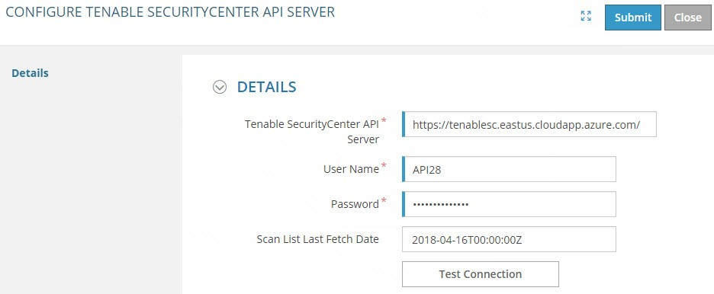

**Figure 84** Configure Tenable SecurityCenter API Server Form

|  |  |
| --- | --- |
| **Field** | **Description** |
| **Tenable SecurityCenter API**  **Server** | Type the SecurityCenter API Server URL. |
| **User Name** | Type the user name of the Tenable SecurityCenter API Server. |
| **Password** | Type the password of the Tenable SecurityCenter API Server. |
| **Scan List Last Fetch Date (YYYY-MM- DDTHH:MM:SSZ)** | Provide the duration from past date to current date that you want to retrieve the scan results. For example, if you want to retrieve the scan results of May 05, 2017 10 AM 10 Minutes and 10 seconds, you can provide input as below: 2017-05-05T10:10:10Z  **Note:** The details that you have provided for the Tenable SecurityCenter API Server URL, User Name, Password, Scan List Fetch Date are stored in the **MS_ITG_Config** table. After you submit the form and run the **MS_TSC_SECURITYCENTER_SYNC_TAV** infolet, the Vulnerability data is fetched. |
| **Test Connection** | Test the connection with Tenable SecurityCenter API Server. |

After entering all the required details in the form, click **Submit** to submit the form.

##### Running Infolet of Tenable SecurityCenter

After submitting the form, you can fetch the vulnerability data from Tenable SecurityCenter by running the

**MS_TSC_SECURITYCENTER_SYNC_TAV** infolet.

To retrieve the vulnerability data from Tenable SecurityCenter by running the infolet, perform the following:

1. Login as SYSTEMI.
2. Navigate to the **Infolets** page.
3. Click the **Run Infolet** link corresponding to the **MS_TSC_SECURITYCENTER_SYNC_TAV** infolet.

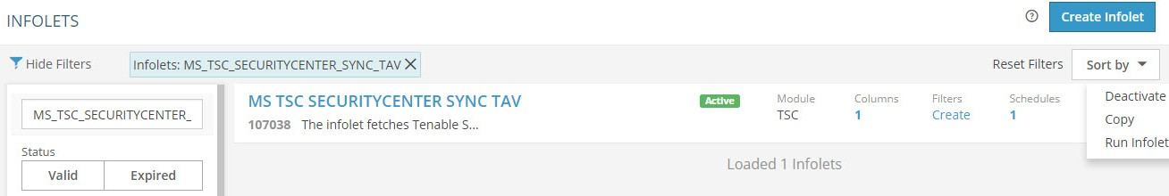

**Figure 85** Running Tenable SecurityCenter Infolet

**Note:** Once you click **Run Infolet**, the retrieved data from Tenable SecurityCenter is stored in the **MsItgCommonTaV**

collection.

##### Setting up Remediation Templates - Tenable SecurityCenter Connector

The first step of managing your threat and vulnerability management program, is to define remediation templates. For setting up template, refer Remediation Templates.

**Note:** The **Remedy** template and **ServiceNow** template is available in your environment based on your subscription.

##### Adding Remediation Rules - Tenable SecurityCenter Connector

After configuring your remediation templates, you need to setup business rules that helps you to prioritize the vulnerabilities to be remediated. The App provides an intuitive rule builder that lets you combine the business context for your assets with the vulnerability context for those assets. A remediation rule (when to trigger the ticket), then ties to a remediation target (where to trigger the ticket) and a remediation template (to whom, to trigger the ticket).

The following rules have been set up for the Tenable SecurityCenter connector:

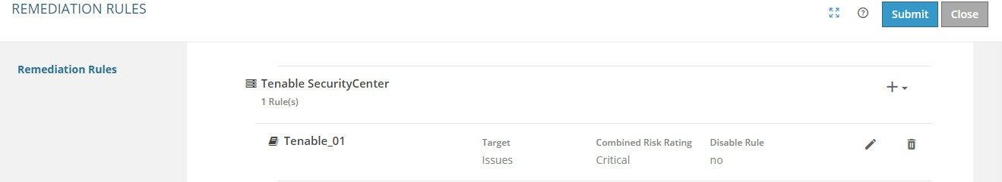

**Figure 86** Adding Remediation Rules - Tenable SecurityCenter

|  |  |
| --- | --- |
| **Field** | **Description** |
| Click + icon to add new remediation rules | |
| **Remediation Action** |  |
| **Name** | Type the name of the rule. |

|  |  |
| --- | --- |
| **Field** | **Description** |
| **Disable Rule** | Select the check box if you do not want to apply the defined rule to create issues or incidents. |
| **Condition** | Displays the rule that is added by using the Rule Expression Wizard window. |
| **Rule Expression Wizard** | Click this button to define remediation rules for issues or incidents. To define rules, perform the following steps:   1. Click the **Rule Expression Wizard** button.   The **Rule Expression Wizard - Tenable SecurityCenter** window appears.   1. Define the rule as required. 2. Click **Submit** to create the rule.   For more information on Rule Expression Wizard - Tenable SecurityCenter window, see Rule Expression Wizard - Tenable SecurityCenter Window. |
| **Combined Risk Rating** | Select the combined risk rating. The available options are:   * Critical * High * Medium * Low |
| **Target** | Select the remediation target. Remediation target defines the target system for issue/incident.   * **Issues**: Select this option if you want to trigger issues in the Issues module.   **Note:** You can select remediation target for manual issue/incident creation by configuring the parameter **MS_ITG_RMD_CONFIG**.   * **Remedy**: Select this option if you want to trigger incident in BMC remedy. * **ServiceNow:** Select this option if you want to trigger incident in ServiceNow. |
| **Template Type** | Select the remediation template type corresponding to the remediation template that you want to add in the rule. The available options are:   * Network Vulnerability Remediation * Web Application Vulnerability Remediation |

|  |  |
| --- | --- |
| **Field** | **Description** |
| **Template Name** | Select the remediation template name that you want to add in the rule.  **Note:** Template names are available for selection based on the selected template type. |
| **Incident Priority**  *Appears only when you select the Remedy option in the Remediation Target field.* | **Urgency**: Select the urgency of the incident. The available options are:   * 1-Critical * 2-High * 3-Medium * 4-Low   **Impact**: Select the impact of the incident. The available options are:   * 1-Extensive/Widespread * 2-Significant/Large * 3-Moderate/Limited * 4-Minor/Localized |

##### Rule Expression Wizard - Tenable SecurityCenter Window

Use this window to define remediation issue creation rules.

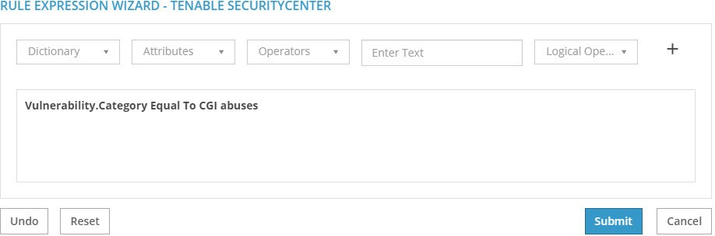

**Figure 87** Rule Expression Wizard - Tenable SecurityCenter Window

|  |  |
| --- | --- |
| **Field** | **Description** |
| **Dictionary** | Select if you want to create a rule for an Asset or Vulnerability. |
| **Attributes** | Select the attribute for which you want to create the rule. This field displays the values based on the value that you select in the Dictionary field. |
| **Operators** | Select the operator. This field displays the operators based on the values that you select in the Dictionary and Attributes fields.  The available options are:   * Equal To * Not Equal To * Greater Than * Less Than * Greater Than Equal To * Less Than Equal To |
| **Value** | Define the value in this field. This field displays the values based on the attribute that you select in the Attributes field. |

|  |  |
| --- | --- |
| **Field** | **Description** |
| **Add icon** | Click this icon to add the rule. |
| **Connecting Operator** | Select the connecting operator. The available operators are:   * **AND**: Select this option to “AND” (combine) two different rules. * **OR**: Select this option to “OR” (either of the options) two different rules. |
| **ADD** | Click this button to add the connecting operator. |
| **Buttons** | |
| **Submit** | Click this button to submit the created rule and close.  Once you submit, the created rule appears in the Rule Condition field of the Remediation Rules form. |
| **Undo** | Click this button to clear the last-entered expression. |
| **Reset** | Click this button to clear the defined rule and reset. |

# Appendix

This section provides the list of supported special characters.

###### Sections:

* + Restricted Special Characters

**Restricted Special Characters**

The following table provides the special characters that are not allowed in the specified form fields and in the template used for data upload.

|  |  |
| --- | --- |
| **Field** | **Restricted special character combinations** |
| **Threat** form -   * **General** section  **Name** field * **Issue** section  **Add Issue**  **Title**   field   * **Issue** section  **Add Action**    **Title** filed  **Threat Actor** form  **General** section   **Title** field  **Vulnerability** form -   * **General** section  **Name** field * **Issue** section  **Add Issue**  **Title**   field   * **Issue** section  **Add Action**    **Title** filed | ^&^ , and ~ #_# @@ @@<- >@@  $^^$ \\|\\|\\| $#$ ||| @#@ _$$_  $$$ %#% &#& ;#~ ;#, #~# [|] |@^| ||^|| !^()^! ^^ <~>  ||!|| <!> <::> <* |? |#| |

For more details on special characters, refer to the MetricStream Platform Configuration Guide Release M7 February 2020.

# Glossary

#### Chart

A graphical representation of data

#### GRC

Governance, Risk, and Compliance

#### Infocenter

A common and user specific page that appears to users after they login to the MetricStream application. The individual items in the infocenter, such as user forms, assignments, and reports appear on this page.

#### Infoport

All related user objects, which are grouped in a single section of the infocenter, that facilitate work.

#### Reports

A tabular representation of data.

# References

You can refer to the following documents:

* + MetricStream Issues User Guide Release M7 February 2020 - User Guide
  + MetricStream Risk Assessments User Guide Release M7 February 2020 - User Guide
  + MetricStream Platform User Guide Release M7 February 2020 - User Guide

## Feedback

MetricStream welcomes your feedback on the quality and usefulness of this document. If you have any documentation-related comments or suggestions, write to [TechPubs](mailto:TechPubs@metricstream.com)